Chem 1 Hour_____ Name________________________________________
Wexler/Steinhorst
Single Replacement vs. Double Replacement Reactions Worksheet 1 (20pts)
Date:
Part I. Single Replacement Reactions
The general format for a single replacement reaction is A + BC B + AC
Reaction Series Table
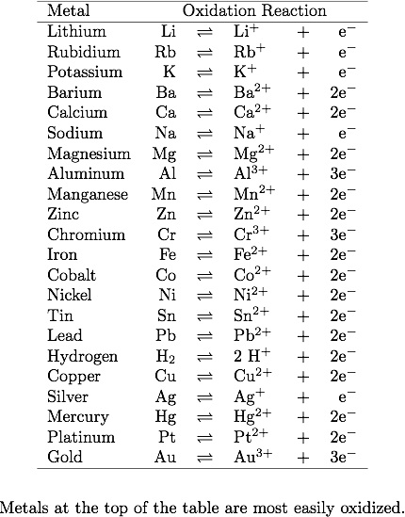(will lose electrons). If a metal is more reactive than a particular cation, then the metal will be able to donate electrons to it (the reaction will go).
Complete each word equation for single replacement reactions, then write them out as balanced chemical equations. Based on the Reaction Series Table above, determine if the reaction will go or not. If it will not go, then write “No Reaction”.
1. Zinc + hydrogen chloride
2. Magnesium + lead(II) sulfate

3. Silver + sodium hydroxide

4. Calcium + potassium chloride

5. Gold + zinc carbonate

Part II. Double Replacement Reactions
The general format for a double replacement reaction is AB + CD AD + CB
Complete each word equation for double replacement reactions, then write them out as balanced chemical equations.
1. Barium chloride + aluminum sulfate

2. Calcium hydroxide + ammonium chloride

3. Potassium iodide + lead (II) nitrate

4. Sodium acetate + calcium sulfide

5. Magnesium sulfate + iron(II) chloride

