Honors Chemistry Hour _____ Name__________________________________________
Dr. Wexler
Test Practice: Ions, Ionic Compounds, Ionic Reactions
Term 3 Week 3 Practice
Do Not Hand In!!!
Answer the following questions on the structure of ions:
1. Compare the calcium atom with its cation:
A. Write the complete electron configuration of calcium
B. Write the complete electron configuration of the calcium cation

C. How many electrons were lost during ionization?

D. What is the purpose of ionization?

E. What is the charge of the calcium cation?

F. From the following list: circle the ions that will bind to the calcium cation:
K⁺¹ Br⁻¹ F⁻¹ N⁻³ Mg⁺² O⁻² Li⁺¹
G. Draw the Bohr model of calcium

H. Draw the Bohr model of the calcium cation

I. Draw the Lewis model of calcium

J. Draw the Lewis model of the calcium cation
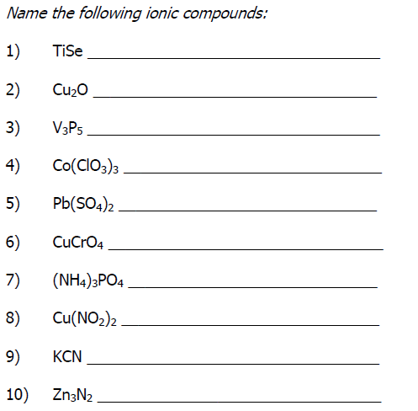
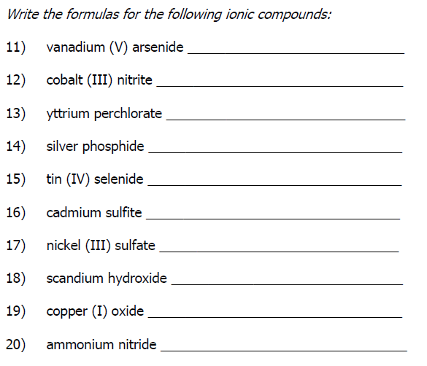

Balance the following chemical reactions:
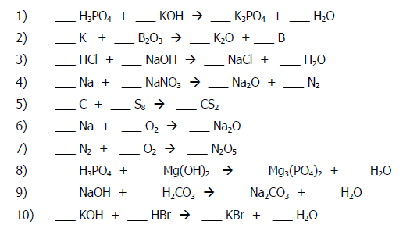
Single Replacement Reactions
A. Complete and balance each reaction
B. Decide whether or not the reaction will occur based on the activity series below:
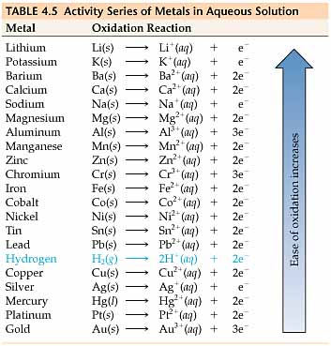
Reaction Go or No Go
1. Ag + KNO₃ ---->
2. Zn + AgNO₃ ---->
3. Al + H₂SO₄ ---->
4. Cl₂ + KI ---->
5. Li + H₂O ---->
6. Cu + FeSO₄ ---->
7. Na + H₂O ---->
8. Fe + Pb(NO₃)₂ ---->
9. Cu + H₂O ---->
10. Cu + AI₂(SO₄) ---->

Double Replacement Reactions:
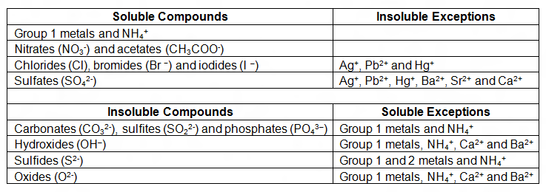
You mix the following two chemicals: barium chloride and potassium sulfate.
1. Write the names of the two products

2. Which of the two products will precipitate out of solution?

3. Write the balanced molecular equation for this reaction. Include the physical states of the reactants and products.

4. Write the complete ionic equation for this reaction. Include the charges on all ions as well as the physical states of the reactants and products

5. Which are the spectator ions?

6. Write the net ionic equation for this reaction. Include the charges on all ions as well as the physical states of the reactants and products.

