Chemistry Hour____ Name____________________________________________
Dr. Wexler
Electron Configuration Worksheet 1
Date assigned______
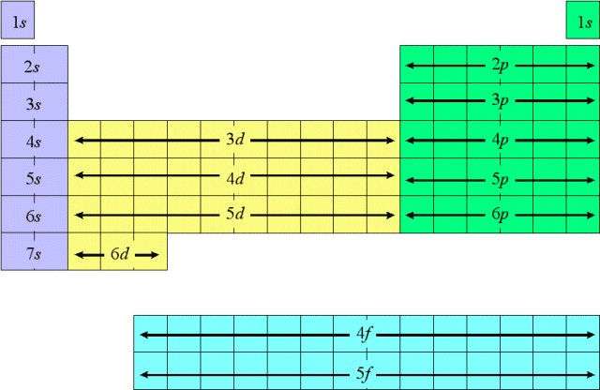
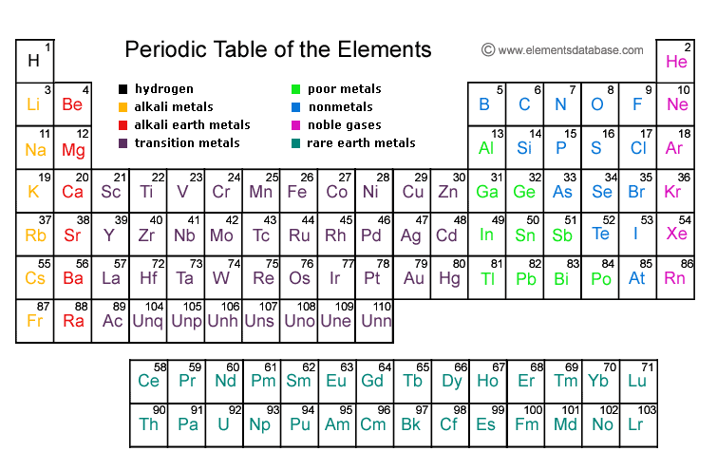

Instructions:
Write the complete, unabbreviated electron configurations for the elements listed below. Do not look up the answer – figure it out based on the number of electrons and the rules for order of filling. All elements are in order of atomic number. The purpose of this exercise is to become familiar with the manner in which electron orbitals are filled.
Example: Fe(26) 1s²2s²2p⁶3s²3p⁶4s²3d⁶
1. H (S-block)
2. He (S-block)
3. Li (S-block)
4. Be (S-block)
5. B (P-block)
6. C (P-block)
7. N (P-block)
8. O (P-block)
9. F (P-block)
10. Ne (P-block)
11. Na (S-block)
12. Mg (S-block)
13. Al (P-block)
14. Si (P-block)
15. P (P-block)
16. S (P-block)
17. Cl (P-block)
18. Ar (P-block)
19. K (S-block)
20. Ca (S-block)
21. Sc (D-block)
22. Ti (D-block)
23. V (D-block)
24. Cr (D-block)
25. Mn (D-block)
26. Fe (D-block)
27. Co (D-block)
28. Ni (D-block)
29. Cu (D-block)
30. Zn (D-block)
31. Ga (P-block)
32. Ge (P-block)
33. As (P-block)
34. Se (P-block)
35. Br (P-block)
36. Kr (P-block)

