Chem 1 Hour_____ Name________________________________________________
Dr. Wexler
Properties of Ionic and Covalent Compounds (HS-PS1-3)
Date_____

Introduction:

Ionic compounds (or salts) are formed when metals transfer electrons to nonmetals. The loss of electrons by the metal atom transforms it into a positive ion, or cation. The gain of electrons by the nonmetal atom transforms it into a negative ion, or anion. The cation and anion are attracted to each other because of their opposite charges. A salt is really a network of cations and anions that are stacked in a specific crystalline structure due to their mutual attractions.

In a covalent compound, atoms share electrons. Covalent bonds are usually formed between nonmetal atoms, which have more valence electrons than they are energetically capable of losing. Nonmetal atoms have reasonably high ionization energies, so it’s hard to get an electron from one. When two nonmetal atoms meet they do not tend to completely transfer electrons (as a metal would do to a nonmetal); instead, they tend to share. One pair of electrons makes a covalent bond, and since both atoms “want” that pair of electrons, they stick together as long as the pair is shared.

Both types of chemical bonds exist because of atoms trying to satisfy the octet rule. The octet rule says that atoms gain, lose, or share electrons in an attempt to achieve the same electron configuration as one of the noble gases (which usually have 8 valence electrons – hence the word “octet”). Noble gases have the most stable arrangements of electrons; this explains why they so seldom participate in chemical reactions.

In today’s experiment, you will determine some properties of ionic and covalent bonds. You will compare their melting temperatures and electrical conductivity in solutions. You will use the observed properties to make conclusions regarding some unknown compounds.

Materials:
Aluminum foil
Hot plate
9-Volt battery
Wires with alligator clips
Buzzer
Glass petri dish

Chemicals:
Distilled water
Sodium chloride (table salt), NaCl
Sucrose (table sugar), C₁₂H₂₂O₁₁

Procedure:

PART ONE: Relative Melting Point Determination

- Cover the hot plate with a square of aluminum foil.
- Place a sample of NaCl on the aluminum foil, about 1 inch from the center of the square.
- Place a sample of sucrose on the aluminum foil on the other side from the NaCl.
- Turn on the hot plate.
- Which compound melts first? Record your observations in the Observations section.
- Make predictions regarding the relative melting points of covalent and ionic compounds in your Conclusions section near the end of this packet (Question C)

PART TWO: Conductivity in Solution

- Use the following schematic to construct a device capable of testing substances for electrical conductivity.

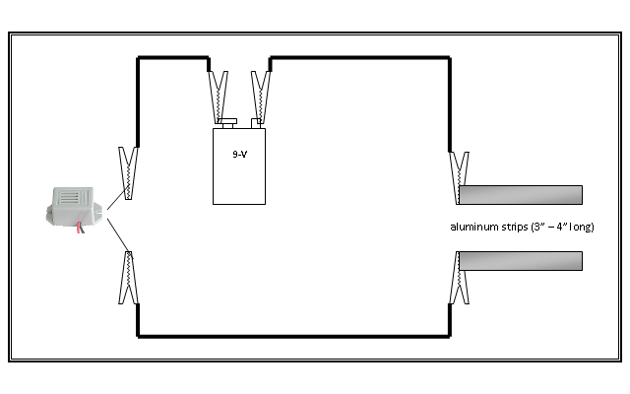
- To test for electrical conductivity, insert both aluminum strips into a solution - if the buzzer comes on, that solution is capable of conducting electricity. If the buzzer does not come on, the material is a non-conductor. Start with distilled water alone. Test it for conductivity. Record your observations.
- Dissolve a teaspoon of NaCl in distilled water. Test the resulting solution for conductivity. Record your observations.

- Dissolve a teaspoon of sucrose in distilled water. Test the resulting solution for conductivity. Record your observations.

- Do ionic compounds conduct an electric current when dissolved? Do covalent compounds? Record your conclusions in the appropriate section.

Data Section:

Record the properties you observed for the samples in the table below:

Unknown Number | Relative Melting Point (Low/High) | Conducts Electricity (yes/no)
Water alone (negative control) | N/A
Sucrose
NaCl

Conclusions:

A. The formula for sodium chloride (table salt) is NaCl. Is sodium chloride an ionic or a covalent compound?

B. The formula for sucrose (table sugar) is C₁₂H₂₂O₁₁. Is sucrose an ionic or a covalent compound?

C. Based on your tests with salt and sugar, which has a higher melting point: ionic compounds or covalent compounds?

D. Based on your tests with salt and sugar, which is a better conductor of electricity: solutions of ionic or covalent compounds?

E. A compound that conducts electricity when dissolved is called an electrolyte. Write a short statement that identifies ionic and covalent compounds as electrolytes or non-electrolytes.

Discussion:
1. Explain your melting point results – what accounts for the difference between the melting points of ionic and covalent compounds? Hint: Compounds melt more easily when there are fewer “ties that bind”, that is, when there are fewer interactions between the individual particles.

2. Explain your conductivity results – what accounts for the difference in conductivity between ionic and covalent compounds?

