Honors Chemistry Hour____ Name_______________________________________
Dr. Wexler
Reactivity of Metals: Single Replacement Reactions and the Metal Activity Series
Date assigned_____
A single replacement reaction involves the replacement of the metal ion of a salt with a different metal ion. For example, calcium may replace magnesium to change calcium chloride to magnesium chloride.
Whether or not this chemical reaction will occur depends on the electronegativities of the metal compared with the metal ion. In general, if the metal has a lower electronegativity than the metal ion (the metal is more reactive), it will replace the ion. For example:
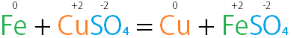
Activity Series
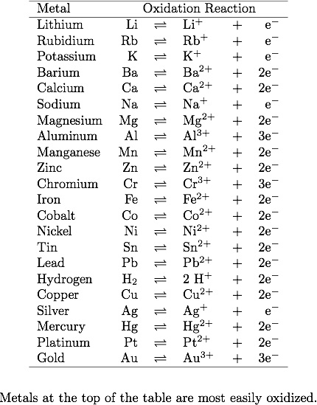
1. Will nickel react with magnesium chloride?
2. Will chromium react with lead sulfate?
3. Will copper react with zinc nitrate?
4. Will calcium react with hydrogen chloride?
5. Will potassium react with lithium sulfate?
6. Will hydrogen gas react with zinc chloride?
7. Will hydrogen gas react with silver nitrate?
8. Which metal is nonreactive in this series?
9. Which metal in this series is the most reactive?
10. When we say that a metal is reactive, do we mean that its non-ionized form (the solid, metallic, neutral form) tends to donate electrons or that it tends to receive electrons?
11. Is there such a thing as a negatively charged metal ion?
12. Will it go? Ba + LiCl BaCl₂ + Li
13. Will it go? Ag+ NiSO₄ AgSO₄ + Ni
14. Write the formulas for the reactants and products of the following single replacement reaction and balance the equation: calcium + sulfuric acid (dihydrogen monosulfate) calcium sulfate + hydrogen gas

