Honors Chemistry Hour_____ Name______________________________________________
Dr. Wexler
Atomic Models Practice 1
Date assigned:
Reference: Chapter 4 in your textbook (Glencoe)
Part I. What is an isotope?
Define here:____________________________________________________________________________________
1. Fill in the empty cells of the following table of five isotopes:
(Note: you will need a periodic table to identify the element)
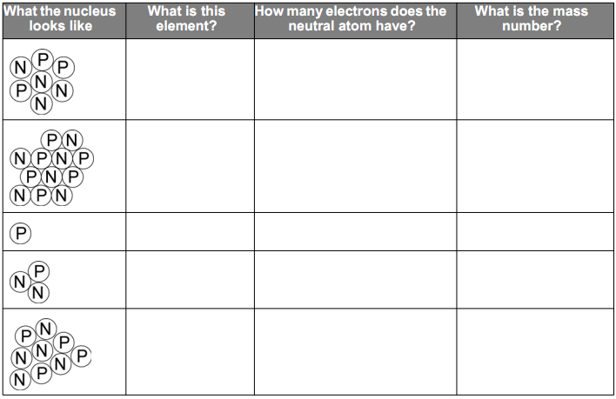
2. Draw a “Bohr” atomic model (both nucleus and electron shell(s) for each of the five isotopes represented in
the table above. Label each model with the name and symbol of the element.

Part II. Answer the following questions: (refer to Glencoe Ch. 4)
1. What is the mass of a single electron?
2. What is the mass of a proton in grams?
3. Calculate the ratio of the mass of a proton to the mass of an electron (show calculations):

4. What is the mass of a neutron? Is it much different from the mass of a proton?

5. The nucleus of an atom consists of what two subatomic particles?

6. Is the nucleus positively or negatively charged?

7. What subatomic particle determines the charge of the nucleus?

8. Explain why atoms are normally neutral in charge?

9. If a neutral atom has 5 protons, how many electrons does it have?

10. The calcium cation Ca⁺² has how many electrons?
11. The chlorine anion Cl⁻¹ has how many electrons?
13. Which subatomic particle is outside of the nucleus?
14. Which two of the subatomic particles account for almost all of an atom’s mass?
A.
B.
15. An isotope of mercury has 80 protons and 120 neutrons. What is the mass number of this isotope? (show calc)

16. Given the isotope Cesium-132:
A. How many protons does it have?
B. How many electrons does it have?
C. How many neutrons does it have?

