Honors Chemistry Hour_____ Name_____________________________________________
Dr. Wexler
Lab: Determining Avogadro’s Number by Electrolysis
Date______
Introduction:
Avogadro hypothesized that a mole contains a specific number of molecules that is the same for all substances, but he never determined that number experimentally. In 1924, one group of scientists did just that by spreading a monolayer (a film one molecule thick) of a chemical of known molecular mass on the surface of water. Since then a variety of other scientific approaches have been devised to accurately make this determination.
What is a mole in terms of mass?
A mole of a substance is its molar mass in grams. For example, one mole of carbon has a mass of 12.01g (its atomic mass). One mole of CH₄ (methane) has a mass of 12.01 + 4(1.01) = 16.05 grams.
What happens during electrolysis?
During electrolysis, electrons flow from the anode (positively charged electrode) towards the power supply. Electrons flow from the power supply into the cathode (negatively charged electrode).
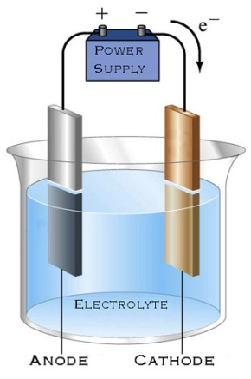
In a regular circuit, the electrons are replenished at the anode. However, in an electrochemical circuit the electrons are not resupplied, causing the anode to lose mass as the metal ionizes (oxidizes – loses electrons). The resulting metal cations dissolve in the water and react with the electrolyte as seen in the example below.
If the anode is copper, and the electrolyte is H₂SO₄, a single replacement reaction occurs:
Cu(s) + H₂SO₄(aq) CuSO₄(aq) + 2H⁺(aq)
The positively charged hydrogen ions are then attracted to the cathode (negatively charged electrode) where they are reduced (gain electrons from the power supply), becoming H₂ gas. Copper ions similarly are attracted to the cathode, becoming reduced to form a metallic copper deposit.
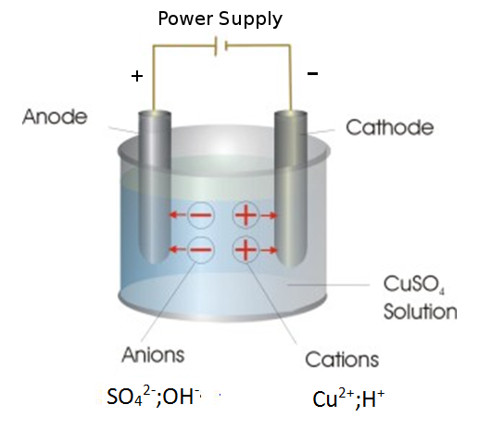
In this experiment:
Electron flow (current in amperes) and time are measured in order to calculate the number of electrons removed from copper atoms to form copper ions (Cu²⁺). This tells us how many copper atoms must have been converted to ions
(1 copper atom oxidized for every 2 electrons removed). We can determine Avogadro’s number by comparing this calculated number of oxidized copper atoms to the measured number of moles of copper atoms lost as determined by weighing the copper before and after electrolysis. The number of atoms per mole is equal to Avogadro’s number.
Objectives:
1. Determine Avogadro’s number by electrolysis of copper metal.
2. Understand the chemical processes occurring during electrolysis of copper.
Special Materials:
Thick copper wire for anode
Thick solder wire for cathode
2 small binder clips to fasten electrodes to beaker
0.5M H₂SO₄ (sulfuric acid)
3 Test leads (1 dual male banana, 2 single male banana/alligator clip)
Power supply, at least 1 amp
Digital Milligram Scale
Stopwatch
250mL Glass beaker
Pre-Lab:
1. What is the accepted value for Avogadro’s number (to three decimal places)?

2. What is the molar mass of copper (Cu)?

3. What happens to copper atoms when they are oxidized?

4. What happens to hydrogen ions when they are reduced?

5. What happens to copper ions when they are reduced?

Procedure:
1. Set up the electrodes, power source, and multimeter in series as shown below. Make sure the power supply is unplugged and the switch is off.
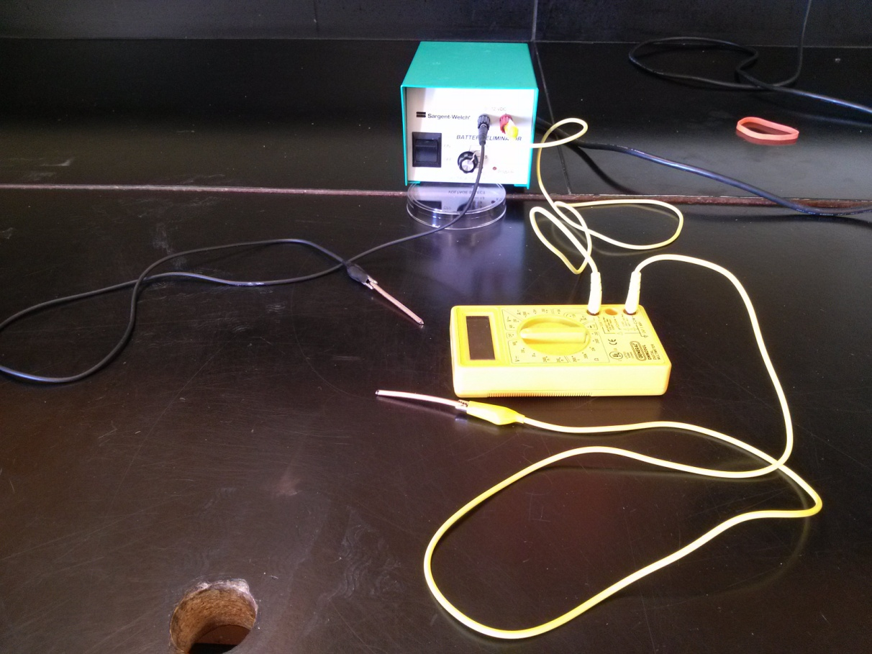
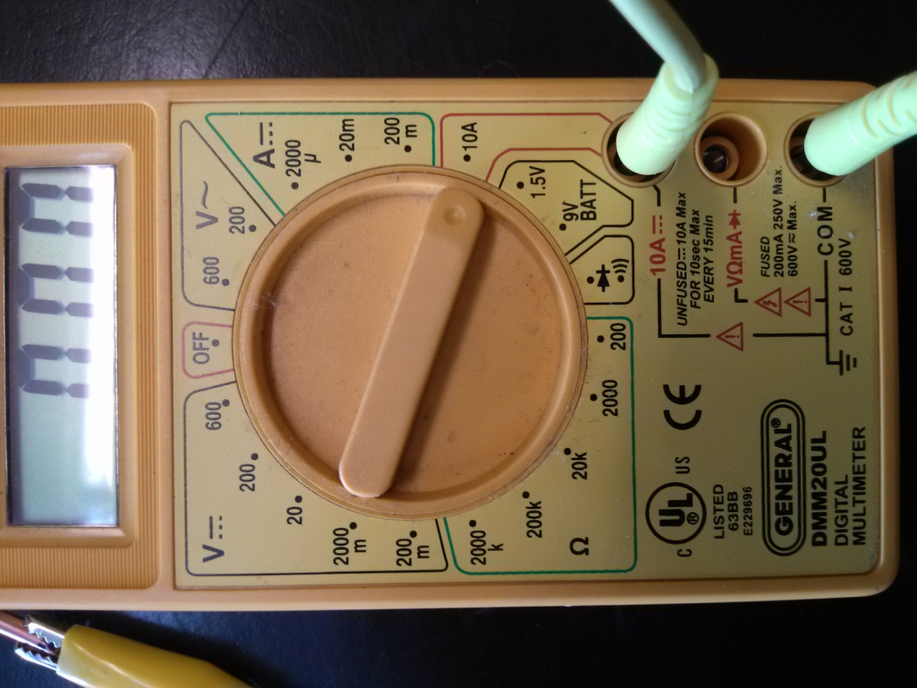
2. Pour about 110mL 0.5M H₂SO₄ into a 250mL glass beaker.
3. Weigh the copper electrode that will be the anode (attached to the red or yellow lead). Take three measurements and average them:
A.
B.
C.
Average:
4. Reattach the copper anode electrode and place both anode and cathode electrodes in the beaker of sulfuric acid as far apart from each other as possible. Only the copper should be immersed in the acid, not the steel alligator clips holding them to the leads. Use binder clips to fasten the leads to the beaker so that the electrodes don’t accidentally touch each other and short circuit.
5. Make sure the dial on the power supply is at its lowest setting.
6. Check that the multimeter is on 10A and displaying “0.00”.
6. Plug in the power supply, making sure the switch is off.
7. Ready your stopwatch.
8. Turn on the power. Turn the dial on the power supply until the multimeter reads between 0.90 and 1.20 Amp. If the power supply model has a maximum current of 1 Amp, do not exceed 1.00 Amp (otherwise a fuse may blow). Start the stopwatch.
9. After a short time the current will decrease sharply, then rebound to about 0.5-0.6 Amp.
Record the current: _______ Amps
Keep track of the current. If it changes, record the change and after how much time this occurred. Consult with your instructor on how best to average the values.
10. Run the electrolysis for exactly 20 minutes (or record the time you actually used if something other than 20 minutes).
11. After 20 minutes, turn the power supply dial all the way to the left, turn off the power supply and unplug it.
12. Wipe the anode dry.
13. Reweigh as before:
A.
B.
C.
Average:
14. Clean both of the electrodes and the alligator clips. Discard the sulfuric acid and rinse the beaker. Put everything back the way you found them.

Analysis: Show all calculations.
1. Calculate the mass of Cu lost from the anode during electrolysis:
Mass before – mass after = mass lost.

2. Calculate the number of seconds for the time of electrolysis:
# min x 60sec/min = # seconds

3. Calculate the charge that passed through the circuit:
Given: 1 Amp = 1 coulomb/second.
# amps x # seconds = # coulombs

4. Calculate the # electrons that passed through the circuit:
Given: one electron has a charge of 1.602 x 10⁻¹⁹ coulomb
# coulombs ÷ (1.602 x 10⁻¹⁹ coulombs/electron) = # electrons

5. Calculate the number of copper atoms lost from the anode:
Given: Two electrons are lost from a single copper atom to form the Cu²⁺ ion.
# electrons ÷ 2 = # Cu atoms lost from the anode

6. Calculate the # moles of Cu lost from the anode:
Mass of Cu lost (g) ÷ molar mass of Cu (g/mol) = # moles of Cu lost

7. Calculate Avogadro’s number:
# atoms Cu lost ÷# moles Cu lost = # atoms/mol = Avogadro’s number

Discussion:
1. Compare your experimental value of Avogadro’s number to the accepted value. What was your % error?
% error = 100 x |experimental - accepted| ÷ accepted

2. Would you consider this to be a successful experiment? Why or why not?

3. What gas was given off at the cathode (black lead)?

4. What was the solid material that deposited on the cathode?

5. What caused the liquid to become a pale blue color? Hint: Cu is a transition metal

