Chem 1 Hour_____ Name______________________________________
Wexler/Steinhorst
Lab: Will it go?
Date______
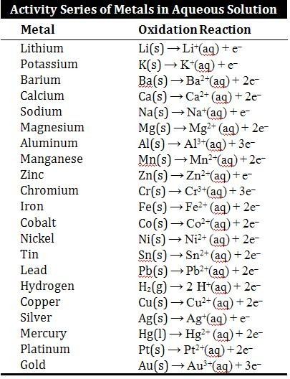
Write out and balance the following reactions. For each, predict if it will “go” or “no go”. Test your predictions with provided materials. Prediction Test Result
1. iron + zinc sulfate iron sulfate + zinc

2. iron + sodium chloride iron(II) chloride + sodium

3. iron + copper(II)sulfate iron(II)sulfate + copper

Prediction Test Result
6. copper + zinc sulfate copper (II) sulfate + zinc

7. copper + sodium chloride copper (I) chloride + sodium

8. copper + hydrochloric acid copper (I) chloride + hydrogen gas

9. copper + tin(II) chloride copper (II)chloride + tin

Prediction Test Result
10. zinc + sodium chloride zinc chloride + sodium

11. zinc + copper(II)sulfate zinc sulfate + copper

12. zinc + hydrochloric acid zinc chloride + hydrogen gas

13. zinc + tin(II) chloride zinc chloride + tin

Prediction Test Result
15. aluminum + sodium chloride aluminum chloride + sodium

17. aluminum + hydrochloric acid aluminum chloride + hydrogen gas

18. aluminum + tin(II)chloride aluminum chloride + tin
Prediction Test Result
19. magnesium + zinc sulfate magnesium sulfate + zinc

20. magnesium + sodium chloride magnesium chloride + sodium

21. magnesium + copper(II)sulfate magnesium sulfate + copper

22. magnesium + hydrochloric acid magnesium chloride + hydrogen gas

23. magnesium + tin(II)chloride magnesium chloride + tin

Questions:
1. Which metal did you expect to produce the most vigorous bubbling with hydrochloric acid? (note- the greatest difference in position in the activity series should yield the strongest reaction.) What did you see?

2. Internet Research Question.
Since sodium chloride is unreactive with iron (according to the activity series and your experimental results), explain why cars rust more in northern states where the roads are salted in winter compared to the south where roads don’t need to be salted. Provide detailed source internet address (url). Use your own words! Do not plagiarize!

