Honors Chemistry Hour______ Name_____________________________________
Dr. Wexler
Flame Tests of Metal Salts Lab (HS-PS1-1)
Date assigned:
Background:
A metal salt is an ionic compound composed of a metal and one or more nonmetals. If a metal salt is heated in a flame, the electrons of the metal atoms will absorb energy and enter an excited energy state. As they do this, they jump to a higher energy level. They then lose this energy in the form of light (photons, which are packets of energy) as they descend to their original energy state (ground state).
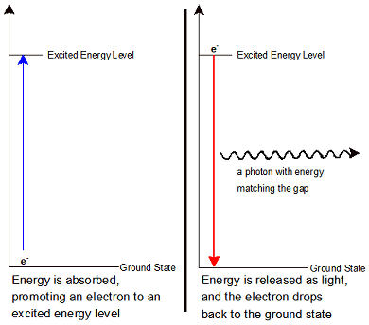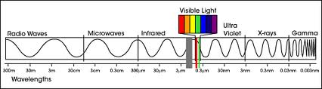
The greater the change in energy the higher the amount of energy in the photons. This increases their wave frequency and therefore their color is towards violet on the electromagnetic spectrum. Small changes in energy lead to a lower wave frequency and therefore the color is towards the red end of the spectrum.
The exact arrangement of electrons in an atom determines the distances of their quantum jumps and therefore the colors emitted. The individual colors emitted are collectively known as the emission spectrum of an element. This serves as a “fingerprint” for the element. When you see a color it is the product of a mixture of different colors. This spectrum of colors can be observed using a diffraction grating. The composition of distant stars can be determined using special telescopes designed to analyze these spectra.
In this lab you will observe and record the flame test color of a variety of metal salts. You should be able to determine which metals have electrons that jump to higher energy levels based on the color of the flame (also which have electrons that jump to lower energy levels).
Materials:
Cotton swabs, a variety of concentrated metal salt solutions
Given:
Metallic salts and their combined atomic emission spectra:
Lithium nitrate: crimson (an intense red)
Sodium nitrate: orange
Potassium chloride: pale violet
Strontium nitrate: red-orange
Copper (II)chloride: blue-green
Copper(II)nitrate: green
Barium nitrate: yellow
Procedure:
1. Dip a cotton swab into an unknown metal salt solution.
2. Heat the tip of the swab in a Bunsen burner flame and record the color emitted.
4. Do this for all the unknown salts provided.
5. Identify the metal salt based on the color emitted in the flame test.
Results:
Sample | Color Observed | Identification of Metal Salt
Control (dH₂O)
1
2
3
4
5
6
7

Research Questions:
1. What is the atomic emission spectrum of an element?

2. List the colors observed in this lab from the highest energy to the lowest energy.

3. Why do the metal salts have to be heated in the flame in order for colored light to be emitted?

4. Colorful light emissions are applicable to everyday life. Give some examples of where you observe colorful light emissions.

