Honors Chemistry Hour_____ Name_____________________________________
Dr. Wexler
Stoichiometry Worksheet 4 (HS-PS1-7)
Date_____
You are given the following reaction:
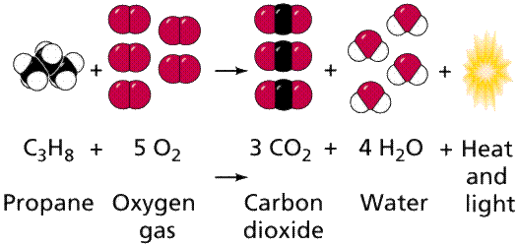
1. Calculate the molar mass of propane (show all calculations)

2. Calculate the molar mass of oxygen (show all calculations)

3. Calculate the molar mass of carbon dioxide (show all calculations)

4. How many moles of oxygen is required to completely react 2.5 moles of propane?

5. How many moles of carbon dioxide is produced from 2.5 moles of propane in excess oxygen?

6. How many moles of oxygen is required to produce 10 moles of water in excess propane?

7. Given 10 grams of propane, how many grams of carbon dioxide will be produced? Use the MaMoMoMa strategy. Show all calculations in three parts. Write neatly!

