Honors Chemistry Hour_____ Name_________________________________
Dr. Wexler
Geometry of Covalent Compounds
Date:
Background
The VSEPR model is the “Valence Shell Electron Pair Repulsion” model. This model minimizes repulsion between shared and unshared electron pairs arranged about a central atom.
These repulsions determine the bond angle, which is the angle between the central atom and two bonded atoms. Unshared (unbonded) electron pairs take up more space than shared pairs and will therefore push bonded atoms towards each other slightly. This affects the shape of the molecule. For example, compare trigonal planar vs trigonal pyramidal in the figure below:
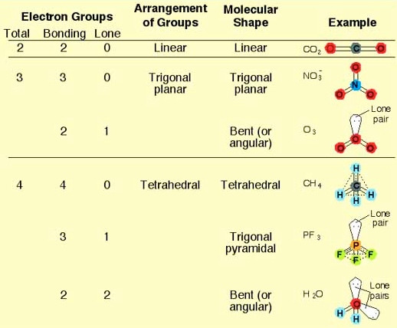

Questions
Determine the shape of the following molecules. Choose from the following options:
Linear, Trigonal planar, Tetrahedral, Trigonal pyramidal, and Bent. Refer to your Lewis Diagrams.
1. F₂

2. O₂

3. H₂S

4. CO₂

5. HCl

6. NH₃

7. H₂

8. N₂

9. PCl₃

10. SiH₄

11. BeCl₂

12. BH₃

