Honors Chemistry Hour_____ Name________________________________________
Dr. Wexler
Electron Configuration and Orbital Diagrams Quiz 1
Date assigned:

1. The further the electron is from the nucleus, the _______________ energy the electron has.

2. A ______________________________ ______________________________ is a region of space in which there is a high probability of finding an electron.
3. How are s orbitals different from p orbitals?

4. How many “s” orbitals can there be in any energy level? ____________________________
5. How many “p” orbitals can there be in any energy level? ____________________________
6. How many “d” orbitals can there be in any energy level? ____________________________
7. How many “f” orbitals can there be in any energy level? ____________________________
8. Which is filled first?
A. s or p? _________
B. p or d?_________
C. f or d?_________
D. s or d?_________
9. State the following Principles:
A. Pauli exclusion Principle

B. Hund’s rule

10.The correct orbital diagram of carbon is:
1s² 2s¹ 2p³
1s¹ 2s² 2p³
1s² 2s² 2p⁴
1s² 2s² 2p²
1s² 2s² 2p⁶

11.Which one of the following is a proper orbital diagram?
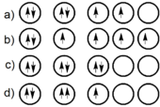
12.Which one of the following is a proper orbital diagram?
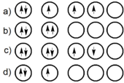

13.1s² 2s² 2p⁴ is the electron configuration for:
Boron
Carbon
Nitrogen
Oxygen
Fluorine

14.1s² 2s² 2p⁶ is the electron configuration for:
Fluorine
Neon
Chlorine
Argon
Sodium

15.Which of the following is an appropriate electron configuration for a neutral sodium atom?
1s²2s²2p⁶
1s²2s³2p⁶
1s²2s²2p⁷
1s²2s²2p⁶3s¹
1s²2s²2p⁶3s²

16.Which one of the following is the proper orbital diagram for a neutral lithium atom?
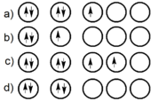

17. There is an error in this orbital diagram. Explain the error.
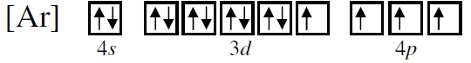

18. There is an error in this orbital diagram. Explain the error.
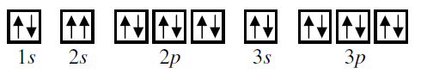

19. Draw the orbital diagram for vanadium

20. Using arrows, show how the following orbitals will fill with electrons.
 | Electron Configuration | 1s | 2s |  | 2p |  | 3s |  | 3p |  | 4s |  |  | 3d
Mg | 1s²2s²2p⁶3s²
Cl | 1s²2s²2p⁶3s²3p⁵
Si | 1s²2s²2p⁶3s²3p²
Ti | 1s²2s²2p⁶3s²3p⁶4s²3d²

21. What is the definition of a valence electron? Why are valence electrons important?

22. List the number of valence electrons for the following atoms:
A. Potassium
B. Magnesium
C. Carbon
D. Nitrogen
E. Cobalt
F. Zinc
G. Bromine

23. Make a general statement about the number of valence electrons in the D-block elements (transition metals). Name the two “single” anomalies in period 4. Name the “double” anomaly in period 5.

