Honors Chemistry Hour_____ Name____________________________________
Dr. Wexler
Hybrid Atomic Orbitals
Date_____

When atoms bond to form molecules, they use molecular orbitals. These are formed through the hybridization of the atomic orbitals s, p, and d.

The hybridized molecular orbitals have different shapes and energy levels than the atomic orbitals. The number of molecular orbitals created by hybridization depends on the number of atomic orbitals that are mixed to form them.

I. sp³ hybridized orbitals:
A. Carbon (when forming carbon tetrachloride, CCl₄)
In forming sp3 hybridized orbitals, four atomic orbitals are mixed, one s and three p. The energy diagram for this process is shown below. The hybridized orbitals are higher in energy than the s orbital, but lower in energy than the p orbitals. Below is an incomplete electron orbital energy diagram for carbon:
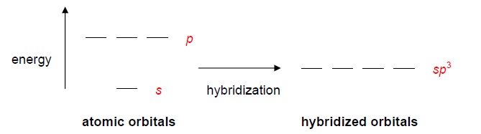
Carbon has 4 valence electrons. Add these electrons to the atomic orbitals on the left and also distribute them in sp3 hybridized molecular orbitals on the right. With this hybridization, C will form four equivalent σ bonds. This hybridization gives the molecule a tetrahedral geometry.

Draw the Lewis diagram for carbon tetrachloride:

How many σ bonds are formed?
How many lone pairs of electrons does carbon have?

Draw a tetrahedron:

B. Oxygen (when forming water, H₂O)
Draw the electron orbital energy diagram for sp3 hybridized oxygen, which has 6 valence electrons (refer to the carbon energy diagram above):

Draw the Lewis diagram for water

How many σ bonds are formed?
How many lone pairs of electrons does oxygen have?

How do the lone electron pairs affect the geometry of the water molecule?

C. Nitrogen (when forming ammonia, NH₃)
Draw the electron orbital energy diagram for sp3 hybridized nitrogen, which has 5 valence electrons. Remember that, as with atomic orbitals, every hybridized molecular orbital must first be filled with one electron before electrons can be paired (Hund’s Rule).

Draw the Lewis diagram for ammonia:

How many σ bonds are formed?
How many lone pairs of electrons does oxygen have?

How do the lone electron pairs affect the geometry of the molecule?

II. sp² hybridized orbitals:
Al (when forming AlCl₃)
In some Lewis structures, only three equivalent bonds are formed. To create three equivalent hybridized sp2 orbitals, mix three atomic orbitals (one s and two p).
Complete the energy diagram below showing orbital hybridization in aluminum.
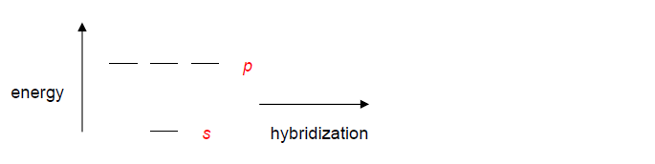
Draw the Lewis diagram for aluminum trichloride:

How many σ bonds are formed?

How many lone pairs of electrons does aluminum have?

This hybridization gives _______________________________ geometry.

What is unusual about the number of electrons around aluminum in aluminum trichloride? What rule does this violate?

Calculate the formal charge on aluminum in this molecule (show your calculations). How does this help explain why the aluminum is stable?

III. sp hybridized orbitals
Be (when forming BeCl₂)
In some Lewis structures, only two equivalent bonds are formed. To create two equivalent hybridized sp orbitals, mix two atomic orbitals (one s and one p).

Complete the energy diagram below showing orbital hybridization in beryllium.
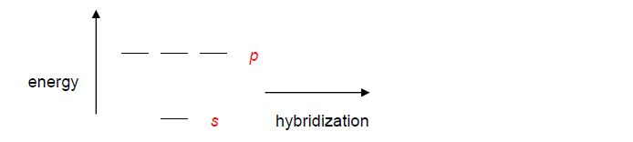

Draw the Lewis diagram for beryllium dichloride:

How many σ bonds are formed?

How many lone pairs of electrons does beryllium have?

This hybridization gives _______________________________ geometry.

IV. sp hybridized orbitals forming double bonds:
In linear molecules, like CO₂, two equivalent hybridized sp orbitals are formed. To create two equivalent hybridized sp orbitals, mix two atomic orbitals (one s and one p). Note that two electron-containing p orbitals remain unhybridized.

Complete the energy diagram below showing orbital hybridization in carbon.

Draw the Lewis diagram for carbon dioxide:

How many σ bonds are formed?

How many π bonds are formed?

Advanced: Carefully diagram and label the orbitals and bonds of CO₂

