Honors Chemistry Hour_____ Name_________________________________________
Dr. Wexler
Solubility and Double Replacement Reactions
Term 3 Week 1
A double replacement reaction will occur between two salts if one or more of the products is insoluble in water (or forms a gas or a liquid). The “removal” of a product drives the reaction forward.
A spectator ion is an ion that is present but is not involved in a chemical reaction. If all the ions in an aqueous solution are spectators, then no chemical reaction has occurred.
If you are given two salts, you must be able to predict whether or not a double replacement reaction will occur between them. This is accomplished by examining the solubility of the products using a set of solubility rules (or a table of solubilities) as shown in the table below:
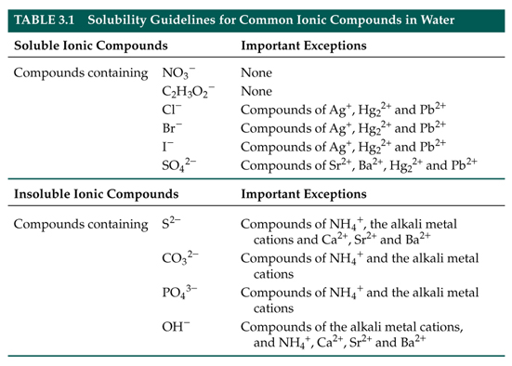
1. Based upon the above rules, predict whether each of the compounds listed is soluble (aq) or insoluble (s):
a. _____K₂CO₃
b. _____CaSO₄
c. _____AgNO₃
d. _____MnPO₄
e. _____PbI₂
f. _____(NH₄)₂SO₃
g. _____Ca(OH)₂
h. _____Pb(C₂H₃O₂)₂
i. _____AgI
j. _____Na₂SiO₄
k. _____FeSO₄
m. _____WCl₄
2. For each of the following double replacement reactions occurring in water solution, write 3 balanced
equations: one in “molecular” form , one in complete ionic form and one in net ionic form (leaving out
spectator ions).

Remember that in ionic forms insoluble materials (precipitates) must be written in molecular
form.

For example:
A. Balanced molecular equation
CuSO₄(aq) + 2NaOH(aq) Cu(OH)₂(s) + Na₂SO₄(aq)
B. Complete ionic equation
Cu⁺²(aq) + SO₄⁻²(aq) + 2Na⁺(aq) + 2OH⁻(aq) Cu(OH)₂(s) + 2Na⁺(aq) + SO₄⁻²(aq)
C. Net ionic equation
Cu⁺²(aq) + 2OH⁻(aq) Cu(OH)₂(s)

Equation 1: KI + Pb(ClO₃)₂
- Balanced molecular equation

- Complete ionic equation

- Net ionic equation

Equation 2: Fe₂(SO₄)₃ + Ba(OH)₂
- Balanced molecular equation

- Complete ionic equation

- Net ionic equation

Equation 3: CaCl₂ + (NH₄)₃PO₄
- Balanced molecular equation

- Complete ionic equation

- Net ionic equation

