Balancing Single Replacement Reactions

In a single replacement reaction, the cation (usually a metal) in a compound is replaced by another, more reactive metal. They always follow this format:
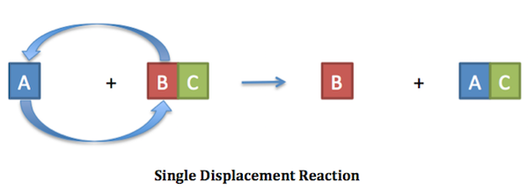

As an example, look at this chemical equation for single replacement reaction between solid lithium and a solution of iron (II) nitrate.
Li_{(s)} + Fe(NO₃)_{2(aq) →} Fe_{(s)} + LiNO_{3(aq)}

Lithium replaced iron (II) in the compound. Iron was left alone as a solid product. This reaction, however, is not balanced. Count the atoms. You might find it helpful to treat the nitrate polyatomic ion as a single element in balancing.

Reactants Products

Li = _ Li = _______

Fe = _ Fe = _______

NO₃ = _ NO₃ = _______

Add coefficients to balance the equation and satisfy the Law of Conservation of Matter.

___Li_{(s)} + ___Fe(NO₃)_{2(aq) →} ___Fe_{(s)} + ___LiNO_{3(aq)}

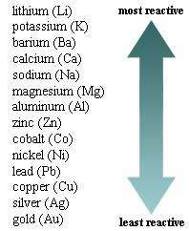
Not all combinations of elements and compounds in single replacement reactions will actually react! You can use the activity series of metals to predict this. Follow these two rules:

- Highly reactive metals prefer to be part of a compound.

- Highly stable metals prefer to be alone.

Look at the following combinations. If they will react, then predict what the products will be. If they will not react, then write NR for o reaction”.

K + Cu₂SO₄ ________________

Al + BaCl₂ ________________

Mg + AlPO₄ ________________

Practice
Balance each of these single replacement equations.

- Cu (s) + AgNO₃(aq) → Cu(NO₃)₂(s) + Ag(s)

- Li(s) + MgCO₃(aq) → Li₂CO₃(s) + Mg(s)

- K(s) + H₂O(aq) → KOH(s) + H₂(s)

- Ba(s) + HgIO₃(aq) → Ba(IO₃)₂(s) + Hg(s)

- Cr(s) + Fe(OH)₂(aq) → Cr(OH)₃(s) + Fe(s)

Write a complete, balanced chemical equation for each single replacement reaction. Include subscripts, and state of matter notation as needed. Don’t forget about the diatomic elements! If no reaction is to occur, write “NR”.

- Hydrochloric acid (HCl) is mixed with solid magnesium.
Write and balance the chemical equation:

- Gold metal is placed inside a test tube with phosphoric acid (H₃PO₄)
Write and balance the chemical equation:

- Solid tin is mixed into a solution of lithium sulfate
- Write the formula for lithium sulfate:
- Write and balance the chemical equation:

- Potassium metal is added to a solution of manganese (II) oxide
- Write the formula for lithium sulfate:
- Write and balance the chemical equation:

