Honors Chemistry Hour_____ Name___________________________________
Dr. Wexler
Advanced Significant Figures
Date:

Note: rules for rounding when the last digit is a ..5:
A. if previous digit is odd round up (0.75 0.8)
B. if previous digit is even and there are no non-zero digits after the 5, round down (0.850.8)
C. if previous digit is even and there is a non-zero digit after the 5, round up (0.851 0.9)
More examples:
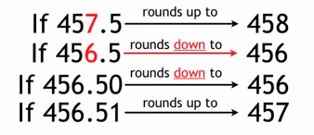

1. (2.756 x 1.20) ÷ (9.5 + 11.28)

2. 82.7 ÷ 0.18 + 114.25

3. (8² – 9) ÷ (12.34 – 19.3)

4. (1.07 – 0.8826) ÷ 0.762

5. (0.91 + 1.2 + 8.4) ÷ 3.700

6. 21.3² – 12.39 + 2.432 x 93.75 ÷ 15

7. (0.7899)(23.98) + (0.1)(24.98) + (0.1101)(25.9)

8. 64.25 + (32.6 x 1.42) ÷ (24.8 – 3.05)

