Honors Chemistry Hour_____ Name__________________________________________   
Dr. Wexler  
Bond Energy Changes Worksheet 1  
Date________

1 Exothermic and endothermic reactions

Decide whether each of these reactions is exothermic or endothermic:

1. When two chemicals mix their temperature rises: _______________
2. A solid burns brightly and releases heat, light and sound: _______________
3. When two chemicals are mixed their temperature drops: _______________
4. Two chemicals will only react if you heat them continually: _______________
5. Plants take in light energy for photosynthesis: _______________

2 Making and breaking bonds

During chemical reactions the bonds between atoms break and new bonds form.

Energy must be absorbed to break a bond, so breaking bonds is endothermic.

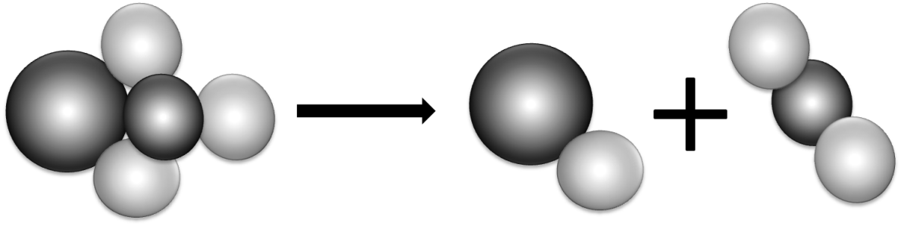Making new bonds is exothermic because energy is released.

1. When green copper carbonate decomposes, the equation is:

|  |  |  |
| --- | --- | --- |
| CuCO3 | CuO | CO2 |
| copper carbonate | copper oxide | carbon dioxide |

Is the reaction exothermic or endothermic? Use ideas about bonds to explain why.

_____________________________________________________________________

1. Draw diagrams to show what happens when hydrogen reacts with oxygen. Mark the bonds broken in blue and the new bonds formed in red. The equation is:

|  |  |  |  |  |
| --- | --- | --- | --- | --- |
| 2H2 hydrogen | + | O2 oxygen |  | 2H2O water |

3 ‘Make or break’

1. 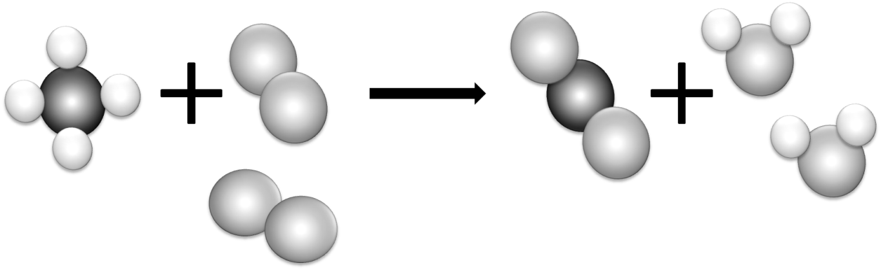Most reactions involve bond breaking and bond making. This equation shows what happens when methane (CH4) burns in oxygen (O2).  
   Mark the bonds broken in blue and the bonds formed in red.
2. Complete the table to show the number of bonds broken and formed:

|  |  |  |  |
| --- | --- | --- | --- |
| Bonds broken | Number | Bonds formed | Number |
| between carbon and hydrogen |  | between carbon and oxygen |  |
| between oxygen atoms |  | between hydrogen and oxygen |  |

1. Is the reaction exothermic or endothermic overall?

________________________________________________________________________

1. The overall energy change is decided by the strength of the bonds that are broken or formed during the reaction. The stronger the bond the larger the energy change.  
   Which bonds must be stronger in this reaction – the bonds broken or the new bonds formed?

________________________________________________________________________

1. An energy level diagram shows the energy taken in and released during the reaction. Add the reactants, products and their separated atoms to the correct places on the diagram.



products

reactants

energy

course of the reaction

1 Comparing fuels

A student wanted to compare the energy released when 4 different fuels burned.

To make it a fair test she put 1 g of each fuel in a little dish. Then she burned each fuel under a calorimeter containing 200 cm³ of water. These are her results:

|  |  |  |  |
| --- | --- | --- | --- |
| Fuel | Temperature at the start in °C | Temperature at the end in °C | Temperature rise in °C |
| methanol | 25 | 56 |  |
| ethanol | 18 | 53 |  |
| propanol | 17 | 54 |  |
| butanol | 23 | 63 |  |

1. Calculate each temperature rise and state which fuel releases most energy per gram.

________________________________________________________________________

Another student used spirit burners for the experiment. She had to weigh them before and after each test to find out how much fuel she had used. To make it a fair test she used each fuel to make the same amount of water 10°C hotter. These are her results:

|  |  |  |  |
| --- | --- | --- | --- |
| Fuel | Mass of burner at the start in g | Mass of burner at the end in g | Mass of fuel used in g |
| methanol | 154.3 | 150.7 |  |
| ethanol | 213.4 | 210.6 |  |
| propanol | 185.8 | 183.4 |  |
| butanol | 198.5 | 196.3 |  |

1. Calculate the mass of each fuel she had to use to release the same amount of energy, and state which fuel must release more energy per gram. Write the mass for each fuel in the table above.
2. Results are reproducible if they lead to the same conclusions when different people do the experiments or when different methods are used. Are the results reported on this page reproducible? Explain.