Honors Chemistry Hour_____ Name______________________________________
Dr. Wexler
Lab: Determining the Molar Mass of Butane (HS-PS1-3; HSN-Q.A.1)
Date _____
Brief Background:
An ideal gas is one which obeys Charles’s Law (V₁/T₁ = V₂/T₂) and Boyle’s Law (P₁V₁ = P₂V₂) exactly.
An ideal gas also obeys the Ideal Gas Law: PV = nRT
where P = pressure (kPa, kilopascals)
V = volume (L, liters)
n = moles of gas
T = temperature (K, Kelvin)
R = gas constant = 8.314 J K⁻¹ mol⁻¹
An Ideal Gas is modeled on the Kinetic Theory of Gases which has 4 basic postulates:
- Gases consist of small particles (molecules) which are in continuous random motion
- The volume of the molecules present is negligible compared to the total volume occupied by the gas
- Intermolecular forces are negligible
- Pressure is due to the gas molecules colliding with the walls of the container
The partial pressure of a gas in a mixture of gases is determined by Dalton’s Law: P_{total} = P₁ + P₂ +….P_{n}. Thus, atmospheric pressure is the sum of the pressures of its component gases, including N₂, O₂, CO₂, H₂O, and others.
Objectives:
Experimentally determine the molar mass of butane using the Ideal Gas Law.
Special Materials:
Butane lighter
Basin of water
100mL Graduated cylinder
Procedure:
1. Measure and record (in the results section) the room temperature(°C)
2. Record (in the results section) the current local barometric (atmospheric) pressure from the internet (inches of Hg)
3. Record (in the results section) the vapor pressure of water at room temperature (use Table 18-2 below, in kPa)
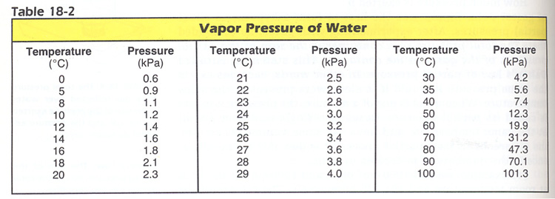
4. Submerse a butane lighter, release a small amount of gas, then dry the lighter with a paper towel. Determine the initial mass of the butane lighter. Record in the data table under Trial 1.
5. Fill a 100mL graduated cylinder to the very top with water. Cover the opening with your hand and invert the cylinder into the basin of water. Be sure no air is trapped in the cylinder, meaning that the cylinder remains completely filled after inversion.
6. Position the butane lighter under water below the opening of the graduated cylinder. Press the lever and release butane gas into the graduated cylinder. Do not allow any of the butane gas to escape outside of the cylinder. Continue collecting gas until the water level in the cylinder is exactly even with the water level in the basin. This insures that the air pressure inside the cylinder to be equal to the air pressure outside the cylinder.
7. Keeping the cylinder inverted, remove the butane lighter.
8. Read the volume of gas collected in the graduated cylinder. Convert mL to L. Record in the data table.
9. Dry the lighter with a paper towel and determine its final mass (g). Record in the data table.
Results:
Volume of butane (L)
Initial mass of butane lighter
Final mass of butane lighter
Mass of butane (Initial – Final)
Room temperature _________________ °C = _________________ K (K =°C + 273)
P_{atm} (atmospheric pressure = _________ inch Hg = __________________kPa
(Note: 1 inch Hg = 3.3864 kPa)
P_{water} (water vapor pressure)= __________________ kPa (from Table 18-2)

Analysis:
1. Calculate the partial pressure of butane inside the cylinder. Using Dalton’s Law: P_{butane} = P_{atm} - P_{water}

2. Determine the molar mass (g/mol) of butane. Show all calculations using the two formulas provided below:
Part A. Moles of butane (n) = (P_{butane} x V_{butane})/(8.314xT) (from the Ideal Gas Law, PV = nRT)
Show your calculations:

Part B. Experimental molar mass of butane = mass of butane ÷ moles of butane (n)(from part A above)) = _________________g/mol
Show your calculations:

3. Calculate the expected molar mass of butane from its chemical formula C₄H₁₀ = ______________ g/mol
Show your calculations:

4. Compare your experimental molar mass for butane to its expected molar mass:
A. % Error for this experiment = 100 x |experimental – expected| ÷ expected = _____________%

B. Discuss possible sources of error in this experiment.

