Chemistry Hour_____ Name_________________________________________
Dr. Wexler
Lab: Determination of the Percent Oxygen in Air (HS-PS1-3; HSN-Q.A.1)
Date_____
Background and Objectives:
Consider for a moment the air that you breathe. Since the time of the ancient Greek philosophers, people have realized that air is critical to life, though with little understanding of why. Experiments by Antoine-Laurent Lavoisier and Joseph Priestley in the 1700’s led to the discovery of oxygen, and in 1785, British chemist Henry Cavendish published a paper reporting that air contained approximately 20% “dephlogisticated" air, or oxygen. We now know that the most common gases in air are nitrogen (78%), oxygen (about 21%), and argon (almost 1%). Other molecules are present in the atmosphere as well, but in very small quantities.
In this laboratory experiment, you will perform a procedure to verify the oxygen content of air. The process to be studied is the reaction of iron in air to form rust (iron oxide).
4Fe(s) + 3O₂(g) 2Fe₂O₃(s)
Anyone who has witnessed rust on a car, bicycle or barbed wire fence knows that this reaction occurs spontaneously, though the rate can be very slow. To hasten the process and complete the data collection in one laboratory period, we will use “activated” iron which contains catalysts – just add air.
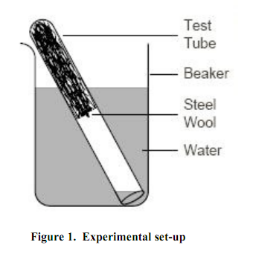
The experimental set-up is similar to that shown in Figure 1 above. The difference is that you will be adding iron mixed with catalyst to the bottom of the tube and holding it in place with a plug of steel wool.
As the oxygen in air (O₂) reacts with iron to form solid iron(III) oxide, the volume of the trapped air will decrease and water will enter the test tube. This change in volume is equal to the volume of oxygen consumed in the reaction. Assuming that the length of the test tube is proportional to its volume and that the change in the length of the column of air in the test tube is due only to the removal of oxygen, the percentage of oxygen can be determined by calculating the change in the volume of air in the test tube.
%O2 = final water level reading (mm)/tube length (mm)
Note: measure the tube length from the rim to the beginning of the iron/catalyst mixture, not the steel wool.
To ensure that all oxygen is completely reacted (the limiting reactant), iron will be in excess.
Special Materials:
Iron/catalyst mixture (from disposable handwarmer)
Steel wool
Ruler
Test tube, large beaker, wood stick
Procedure:
1. Fill a 1000mL beaker about 3/4 full with water.
3. Add a small amount of iron/catalyst mixture to the bottom of the test tube and plug with a small amount of steel wool, loosely packed. Test to make sure this material stays in place by inverting the tube.
5. Measure the initial length of the air column – from the lip of the test tube to the top of the iron/catalyst layer (not to the top of the steel wool layer since it is loosely packed and is mostly air):
_____________________mm
6. Place the prepared tube upside down into the beaker of water, being careful to avoid getting water inside the tube. Lean it against the side of the beaker.
7. Examine the change in the level of water in the test tube over time. When the level stops changing, the oxygen is depleted and the experiment is finished. This should take at least 30 minutes.
8. Measure and record the water level after raising the test tube vertically until the water level in the test tube is even with the water level in the beaker. This eliminates air compression due to the force of the water column.
The water level in millimeters from the lip of the test tube = ________________ mm

Analysis:
1. Calculate the percent of oxygen in air:
100 x (water level length/initial air column length)= ______________________%

2. The expected value for % oxygen in air is 20.8%. Calculate the % error for your experiment.
If you recall, % error is 100|experimental – expected|/expected

Critical Thinking Question:
If you had done this experiment at the top of Mt. Everest, would the results have been the same or different? Explain your answer.

