Chem 1 Hour_____ Name_________________________________________
Wexler/Steinhorst
Readings in Climate Change 1: Introduction and Sea Level Rise
Date:

Instructions: You will be doing a close reading and annotation of this article. However, you will not annotate all at once. Today you will start with vocabulary. Circle what you consider to be key vocabulary and place a star above all circled terms that you can’t define.

Climate change: How do we know?
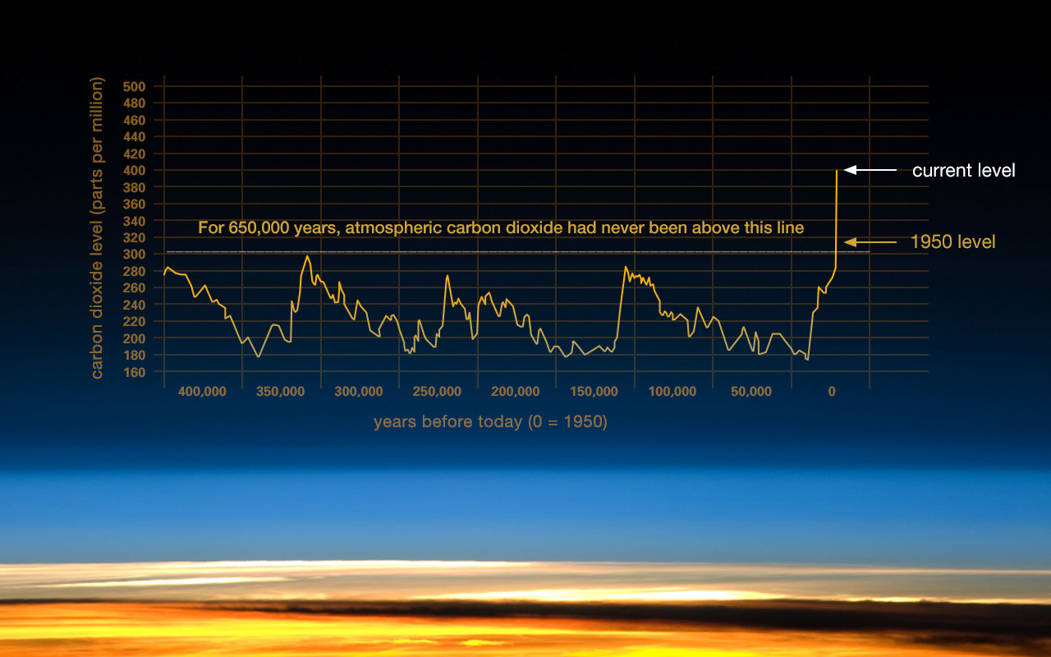
This graph, based on the comparison of atmospheric samples contained in ice cores and more recent direct measurements, provides evidence that atmospheric CO₂ has increased since the Industrial Revolution. (Credit: Vostok ice core data/J.R. Petit et al.; NOAA Mauna Loa CO2 record.)
Scientific evidence for warming of the climate system is unequivocal.
- Intergovernmental Panel on Climate Change
The current warming trend is of particular significance because most of it is very likely human-induced and proceeding at a rate that is unprecedented in the past 1,300 years.¹
Earth-orbiting satellites and other technological advances have enabled scientists to see the big picture, collecting many different types of information about our planet and its climate on a global scale. This body of data, collected over many years, reveals the signals of a changing climate.
The heat-trapping nature of carbon dioxide and other gases was demonstrated in the mid-19th century.² Their ability to affect the transfer of infrared energy through the atmosphere is the scientific basis of many instruments flown by NASA. There is no question that increased levels of greenhouse gases must cause the Earth to warm in response.
Ice cores drawn from Greenland, Antarctica, and tropical mountain glaciers show that the Earth’s climate responds to changes in greenhouse gas levels. They also show that in the past, large changes in climate have happened very quickly, geologically-speaking: in tens of years, not in millions or even thousands.³

The evidence for rapid climate change is compelling:

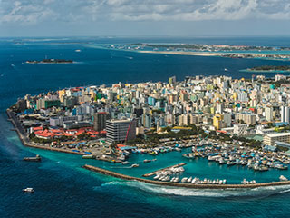
Republic of Maldives: Vulnerable to sea level rise. Credit: Chumash Maxim/Shutterstock.com

Sea level rise

Global sea level rose about 17 centimeters (6.7 inches) in the last century. The rate in the last decade, however, is nearly double that of the last century.

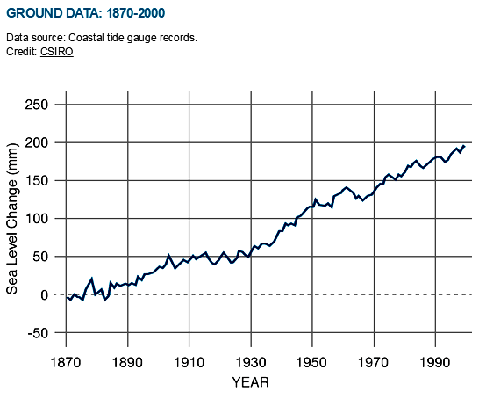
.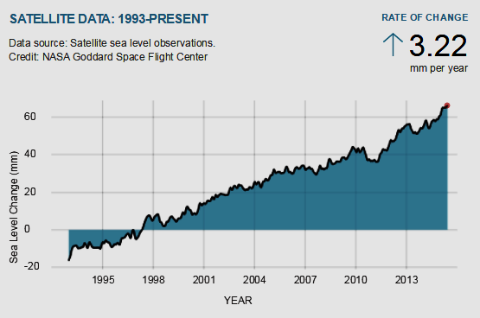
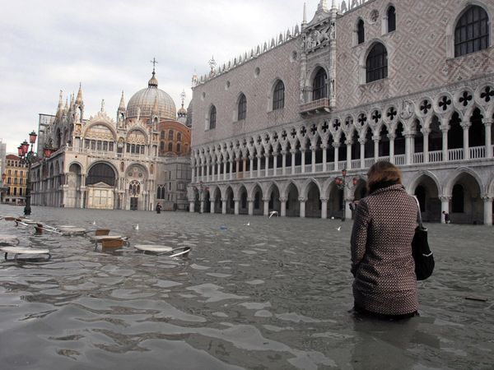
Scientific research indicates sea levels worldwide have been rising at a rate of 0.14 inches (3.5 millimeters) per year since the early 1990s. The trend, linked to global warming, puts thousands of coastal cities, like Venice, Italy, (seen here during a historic flood in 2008), and even whole islands at risk of being claimed by the ocean.
Core samples, tide gauge readings, and, most recently, satellite measurements tell us that over the past century, the Global Mean Sea Level (GMSL) has risen by 4 to 8 inches (10 to 20 centimeters). However, the annual rate of rise over the past 20 years has been 0.13 inches (3.2 millimeters) a year, roughly twice the average speed of the preceding 80 years.
Over the past century, the burning of fossil fuels and other human and natural activities has released enormous amounts of heat-trapping gases into the atmosphere. These emissions have caused the Earth's surface temperature to rise, and the oceans absorb about 80 percent of this additional heat.
The rise in sea levels is linked to three primary factors, all induced by this ongoing global climate change:

Thermal expansion: When water heats up, it expands. About half of the past century's rise in sea level is attributable to warmer oceans simply occupying more space.

Melting of glaciers and polar ice caps: Large ice formations, like glaciers and the polar ice caps, naturally melt back a bit each summer. But in the winter, snows, made primarily from evaporated seawater, are generally sufficient to balance out the melting. Recently, though, persistently higher temperatures caused by global warming have led to greater-than-average summer melting as well as diminished snowfall due to later winters and earlier springs. This imbalance results in a significant net gain in runoff versus evaporation for the ocean, causing sea levels to rise.

Ice loss from Greenland and West Antarctica: As with glaciers and the ice caps, increased heat is causing the massive ice sheets that cover Greenland and Antarctica to melt at an accelerated pace. Scientists also believe meltwater from above and seawater from below is seeping beneath Greenland's and West Antarctica's ice sheets, effectively lubricating ice streams and causing them to move more quickly into the sea. Moreover, higher sea temperatures are causing the massive ice shelves that extend out from Antarctica to melt from below, weaken, and break off.

Consequences
When sea levels rise rapidly, as they have been doing, even a small increase can have devastating effects on coastal habitats. As seawater reaches farther inland, it can cause destructive erosion, flooding of wetlands, contamination of aquifers and agricultural soils, and lost habitat for fish, birds, and plants.
When large storms hit land, higher sea levels mean bigger, more powerful storm surges that can strip away everything in their path.
In addition, hundreds of millions of people live in areas that will become increasingly vulnerable to flooding. Higher sea levels would force them to abandon their homes and relocate. Low-lying islands could be submerged completely.

How High Will It Go?
Most predictions say the warming of the planet will continue and likely will accelerate. Oceans will likely continue to rise as well, but predicting the amount is an inexact science. A recent study says we can expect the oceans to rise between 2.5 and 6.5 feet (0.8 and 2 meters) by 2100, enough to swamp many of the cities along the U.S. East Coast. More dire estimates, including a complete meltdown of the Greenland ice sheet, push sea level rise to 23 feet (7 meters), enough to submerge London.

