Chem 1 Hour_____ Name______________________________________________
Dr. Wexler
Critiquing Results of an Experiment Practice
Date:
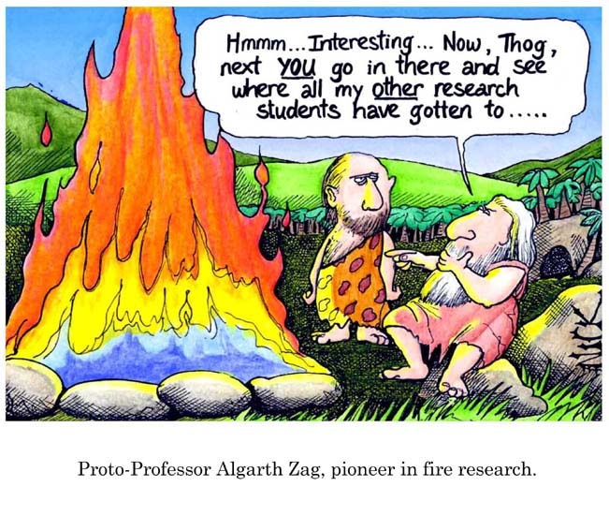
Introduction:
In quantitative sciences like chemistry, a hypothesis must be grounded in existing knowledge. Two kinds of measurable variables must be stated in a hypothesis for that hypothesis to be useful.
The first variable is the manipulated (independent) variable.
The second variable(s) is the responding (dependant) variable. This is your data.
Experimental Scenario:
A behavioral scientist was interested in determining if sexual attraction is determined by circumstance.
His hypothesis was: If a man meets a woman under dangerous circumstances then the man will be more sexually attracted to the woman.
He tested his hypothesis by having a woman researcher randomly meet unselected male test subjects who happen to be either on a sturdy pedestrian bridge or a wobbly pedestrian bridge that swayed. While on each bridge, the woman gave the men she met her phone number and asked them to call.
The results of this experiment were:
Men on stable bridge: 12% called .
Men on wobbly bridge: 50% called.

Questions:
1. What was the manipulated variable?
2. What was the responding variable?

3. The researcher initially concluded that a man who meets a woman under dangerous or otherwise exciting circumstances will be more attracted to the woman than if they meet under ordinary circumstances.
After thinking about it for a while, however, the researcher realized that although the results were significant, his interpretation of the results was not necessarily correct.
What other explanation for these results did the researcher think of?

