Density
Density measures the ‘heaviness’ of an object or how closely ‘packed’ the substance is. Density is related to both the type of material that an object is made of and how closely packed the material is.
Why do I care? When planting crops or plants, soil density is very important. If the soil is packed too tightly, the plant or crop won't be able to absorb any water or nutrients from the soil and will not be able to grow properly. Density in the atmosphere is also important in the formation of clouds and precipitation.

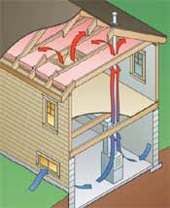
Air Circulation Relative to Density

What is density? The technical definition of density is mass per unit volume. Generally, density describes how tightly packed something is. An object with a lot of material in a small space is more dense than an object that has lots of air space included. In the atmosphere, gas that is less dense has a lower concentration of molecules per volume than a denser gas and will tend to rise compared to the air around it. For example, gasoline vapor is heavier than air molecules and so tends to stay near the ground when you fill up your gas tank, which can lead to a fire hazard if the lingering vapor encounters a spark.
Density and the Atmosphere Warm air is less dense than cooler air. Air density varies with the humidity (water vapor) and temperature. Water vapor molecules are composed of hydrogen and oxygen molecules (H₂O). Dry air is composed mostly of nitrogen molecules (N₂) since Earth's atmosphere is 78% Nitrogen and 21% Oxygen. Since water vapor is lighter than nitrogen gas, an increase in humidity reduces air density.
The density of air particles also decreases with height, with more gas particles remaining near the surface of Earth due to the pull of gravity.
Higher temperatures decrease air density because hot molecules move faster and therefore bounce against each other with more strength. This causes them to move farther apart. Since less dense air rises, warmer air rises. You can notice the effects of this if you live in a two-story house as the upstairs tends to be warmer than the downstairs. Areas of warm rising air often result in the development of clouds and even precipitation in the regions where the vertical movement of air is strongest.
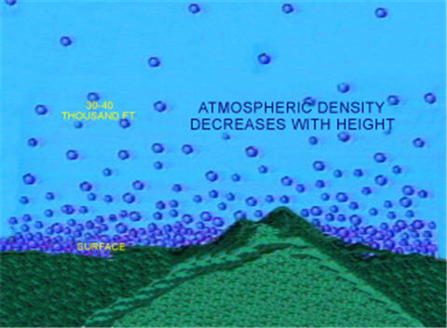 Air Density Decreases with Height

Hot Air Balloons A hot air balloon is a good example of how people work with density (Figure B). Hot air balloons use the properties of density in order to float. In the base of the hot air balloon, there is a propane burner that heats up the air inside of the balloon. When the air inside the balloon becomes warmer than the surrounding air, the balloon will begin to float.
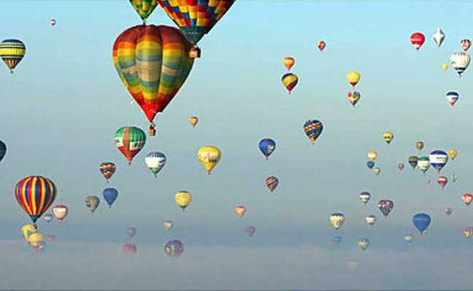
Agriculture Density can be used to explain variations in soil textures. See the diagram below of the three main types of soil particles: sand, silt and clay.
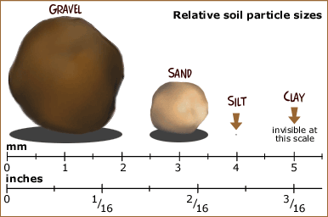
Soil that is very dense and has few air pockets has become this way through compaction.
Compaction makes it harder for water and air to penetrate the soil around the roots of your crop, which makes it hard for the plants to grow.
Compacted soil results in less root growth, because it creates a barrier that makes it difficult for roots to have access to oxygen, water, and nutrients from the soil.
On the other hand, compacted soil is a good thing when it comes to things like building roads or buildings. Construction engineers work very hard to compact soil in order to lend stability to structures.

