Honors Chemistry Hour_____ Name________________________________________
Dr. Wexler
Detergents vs Soap
Date:
SURFACTANTS
What do they do? Surfactants are the active cleaning agents that perform three major roles: • penetrating and wetting fabric • loosening soils (assisted by the mechanical action of the washing machine) • emulsifying soils and keeping them suspended in the wash solution How do they work? Surfactants have two domains within the one molecule: a polar, or hydrophilic (“water-loving”) head group, and a non-polar, “fatty” or hydrophobic (“water-hating”) tail. The basic principle at work is that polar substances interact well with other polar substances, and non-polar substances interact well with other non-polar substances.

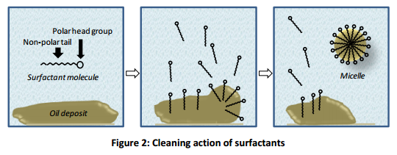
THE PROBLEM WITH SOAP
Although soap is a good cleaning agent, its effectiveness is reduced when used in hard water. Hardness in water is caused by the presence of mineral salts – mostly those of calcium and magnesium. These mineral salts react with soap to form an insoluble precipitate known as soap scum.
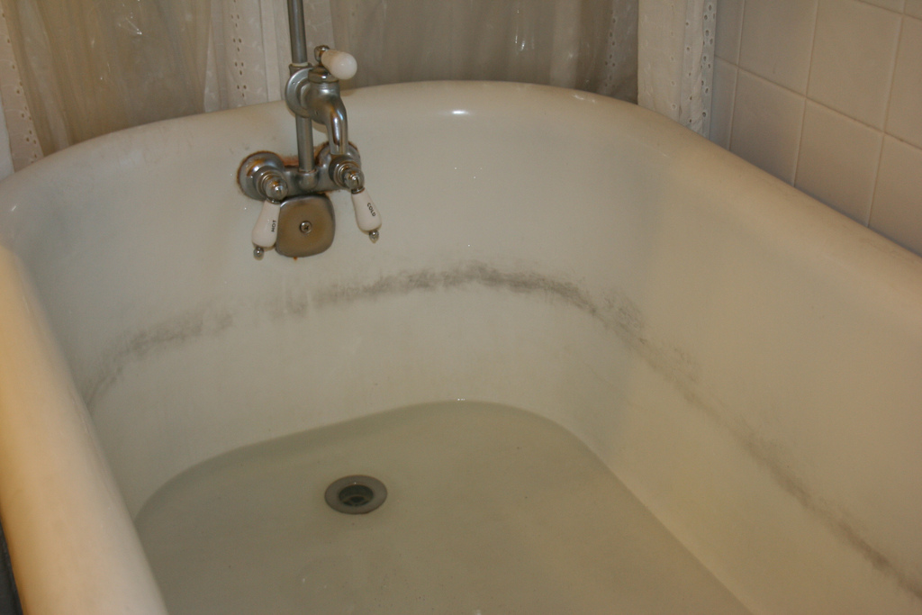
DETERGENTS VS SOAP
Detergents are similar to soap but have structural differences as seen below:
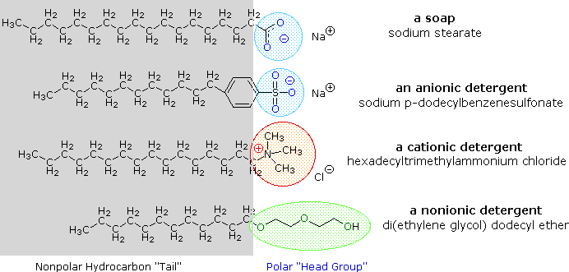
Detergents do not react with calcium and magnesium cations as easily as soap.
1. Explain why hard water reduces sudsing when using soap:

2. Explain why detergents rather than soap are used in hair shampoo and for laundry:

3. Explain why washing soda or borax were added to one’s laundry before the invention of detergents:

