Global Warming's Great Hiatus Gets Another Debunking

Scientists had struggled to understand a slowdown in the world’s warming starting 15 years ago. A new study says it never happened.
By Katherine Bagley, InsideClimate News
Jun 4, 2015
Credit: NOAA's National Centers for Environmental Information
The long-debated hiatus or pause in global warming, championed by climate denialists who tried to claim it proved scientists' projections on climate change are inaccurate or overblown, probably did not happen at all.
A new study by researchers at the National Oceanic and Atmospheric Administration finds that the world’s warming never really stalled during the last 15 years—it was just masked by incomplete data records that have been improved and expanded in recent years.
"The rate of temperature increase during the last half of the 20th century is virtually identical to that of the 21st century," said Tom Karl, director of NOAA's National Centers for Environmental Information and lead author of the study.
The research, published in the peer-reviewed journal Science this week, is just the latest in a growing number of studies refuting the idea of a slowdown or stop in global warming.
"Tom Karl and colleagues have done solid work here, but they’ve mostly just confirmed what we already knew," said Michael Mann, a climate scientist and director of the Earth System Science Center at Pennsylvania State University. "There is no true ‘pause’ or ‘hiatus’ in warming."
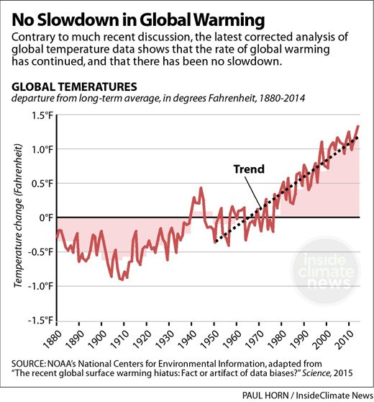
Global temperature trends are calculated using measurements from weather stations on land and by ships at sea. Until recently, stations in regions including Asia, South America and Africa were scarce. Ships collecting temperatures did so first by gathering water either in wooden buckets, in canvas buckets, by thermometers positioned near engine intake valves, and later buoys—resulting in temperature measurements that varied slightly by collection method and requiring correction.
Previous calculations estimated the world had warmed 0.113 degrees Celsius per decade from 1950 to 1999, and 0.039 degrees Celsius per decade from 1998 to 2012, according to the United Nations' Intergovernmental Panel on Climate Change. Global surface temperature "has shown a much smaller increasing linear trend over the past 15 years [1998-2012] than over the past 30 to 60 years," the IPCC concluded in its Fifth Assessment report.
Within the last decade, thousands of new weather stations have been built in previously under-reported areas on land and a vast network of buoys have been deployed that more accurately measure sea surface temperatures. Karl and colleagues reanalyzed global temperature trends with the new data and corrected for ocean temperature discrepancies.
The NOAA scientists found that the world warmed 0.086 degrees Celsius per decade between 1998 and 2012, more than double the previous estimates. When the researchers included 2013 and 2014—when record-breaking heat spread across the globe—warming per decade jumped to 0.116 degrees Celsius.
The "newly corrected and updated global surface temperature data from NOAA's NCEI do not support the notion of a global warming 'hiatus,'" wrote the study authors.
The scientists argue the findings even underestimate the world's warming because they don't consider what has happened in the Arctic, where temperatures have increased rapidly in recent decades, but where there is a limited number of weather recording stations.
"The fact that such small changes to the analysis make the difference between a hiatus or not merely underlines how fragile a concept it was in the first place," said Gavin Schmidt, a climate scientist and director of the NASA Goddard Institute for Space Studies who was not involved in the research.
Mann said the study doesn't prove that warming never slowed, but rather that when it did, it was short-lived, localized and had little impact on the world's overall warming trend over the last century.
"There was definitely a slowdown in warming from around 2000-2012 centered in the Pacific, but leading to a slowing of warming over the Northern Hemisphere," said Mann. That local event barely impacted the global mean temperature at the time.
"There certainly is variability from year to year, and one can find periods in the record where there are small changes," but over the long term, the world is still warming at an alarming rate, Karl said.

