Chem 1 Hour_____ Name_________________________________________
Wexler/Steinhorst
Lab: How many molecules of chalk are in your signature?
Background
Chalk is a soft white limestone called calcite (calcium carbonate) formed from the skeletal remains of microscopic sea creatures called coccolithophores.
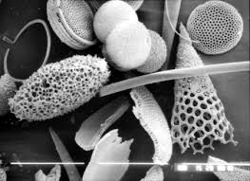
Ninety million years ago the chalk downland of Northern Europe was ooze accumulating at the bottom of a great sea. Protozoans such as foraminifera lived on the marine debris that showered down from the upper layers of the ocean. Their shells were made of calcite extracted from the rich sea-water. As they died a deep layer gradually built up and eventually, through the weight of overlying sediments, became consolidated into rock. Later earth movements related to the formation of the Alps raised these former sea-floor deposits above sea level.
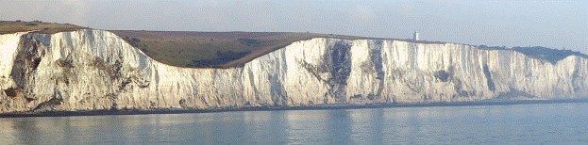
As found in nature, chalk has been used for drawing since prehistoric times, when, according to archaeologists, it helped to create some of the earliest cave drawings. Modern chalkboard chalk is generally made from the mineral gypsum (calcium sulfate), often supplied in sticks of compressed powder about 4 inches long.
Objective
Experimentally determine the number of chalk molecules in your signature on a chalkboard.
Procedure and Results
1. What is the formula for calcium sulfate?

2. What is the molar mass of calcium sulfate? (show your calculations)

3. Weigh a piece of chalk = _______________ g
4. Use this chalk to write your signature. Be careful not to break the chalk and leave as little on your fingers as possible.
5. Reweigh the chalk = _________________ g
6. How many grams of calcium sulfate are in your signature (show all calculations)

7. Using your calculation for grams in step 6, calculate how many moles of calcium sulfate are in your signature (show all calculations)

8. Using your calculation for moles in step 7, calculate how many molecules of calcium sulfate are in your signature (show all calculations)

