Honors Chemistry Hour_____ Name_____________________________________________________
Dr. Wexler
Lab: Analyzing Artificial Snow
Date:
Background:
“Instant Snow” Polymer is made by cross-linking molecules of sodium polyacrylate to form a polymer, the powder in super absorbent diapers. When water is added, the dry polymer beads hydrate and expand, forming small, fluffy clusters that do not cling to surrounding clusters.
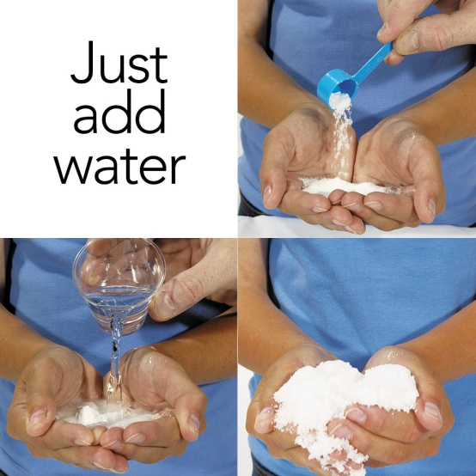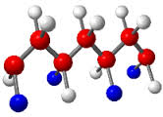

Purpose: To experimentally determine the amount of water to add to a gram of Instant Snow in order to maximize its volume.
Procedure:
1. Place 0.75g of polymer in a plastic cup.
2. Pipet 10mL water into the polymer and stir with a spoon.
3. Pour through a funnel into a 100mL graduated cylinder.
4. Record the polymer volume to the nearest milliliter in the data table.
5. Pour the polymer back into the cup.
6. Repeat with another 10mL.
7. Keep repeating until you have added a total of 70mL water.
8. Graph your data: Volume of Water (mL) on the X-axis and Polymer Volume (mL) on the Y-axis.

Results:
Data Table
Volume of Water Added (mL) | Polymer Volume (mL)
10
20
30
40
50
60
70

Conclusions:
Show all calculations!
1. Based on your results, how much water should be added to 0.75g polymer for it to expand to its maximum volume?

2. Calculate how much water to add to 1.00g polymer to achieve its maximum volume:

3. According to your results, what was the maximum volume (mL) for 0.75g polymer?

4. Calculate the expected maximum volume for 1.00g polymer:

5. Based on your answer to (4), calculate the grams of polymer needed if you wanted to make 1 liter of instant snow.
Note: 1 liter = 1000 milliliter

