Honors Chemistry Hour_____ Name_____________________________________________
Dr. Wexler
Lab: Determining the Density of Water
Date assigned:
Introduction
It is important to have a good understanding of what mass and volume are in scientific terms as well as how these quantities are measured and expressed. We use a “unit” to express a quantity of mass or volume. SI (Standard International) Base Units are determined by international agreement. Prefixes are added to the base units to make them bigger or smaller in scale.
Bigger: Kilo- means 1000
Smaller: Milli- means 1/1000, or 0.001
Referring to the picture below, one kilogram contains 1000 grams (not drawn to scale, but you get the idea that a gram is much smaller than a kilogram).
By the same token, one gram contains 1000 milligrams. Again, a milligram is much smaller than a gram.
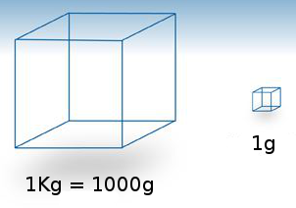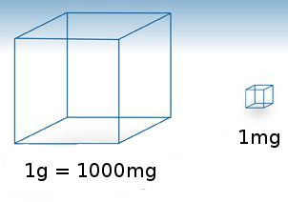
Prelab:
Refer to your definitions of mass and volume, and refer to Table 2-2 p.26 in your textbook, to answer the following questions:
1. Matter is defined as anything that has _________________ and ____________________________________.
2. Mass is a measure of the amount of ______________________ in an object.
3. Volume is defined as the amount of ____________________ taken up by an object.
4. According to your textbook, mass is measured in terms of the following SI base unit:______________ (refer to p. 27 in your textbook).
5. Order the units gram, milligram and kilogram in order from largest to smallest:
(Largest)
_________________________
_________________________
_________________________
(Smallest)
6. How many grams are in one kilogram? _____________________
7. How many milligrams are in one gram? ____________________
8. Ok, here’s a harder one: How many milligrams are in one kilogram?______________________
9. Here’s another harder one: How many kilograms are in one gram? _______________________

Purpose:
To become familiar with the use of the graduated cylinder for measuring volume, and the digital scale for measuring mass.
To understand units of measurement, including how to use a formula to construct a derived unit for density.
Procedure:
1. Pour less than or equal to 100.0 mL of water into the graduated cylinder. Record the exact volume, estimated to the 10th decimal place (such as 96.4 mL).
How do you read a graduated cylinder? You have to line up the bottom of the meniscus (that’s the curvy part at the top of the liquid in the cylinder) with the graduations.
The trick is to look at the meniscus at eye level. Otherwise you will be thrown off by parallax (try it – look at the meniscus from above or below. You will get different readings).
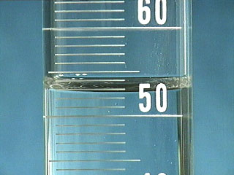
Make sure you figure out the value of each graduation line. In the 100 mL cylinder (see above image), each interval is 1.0 mL.
Counting up from 50: 51, 52…stop. The meniscus is between 52 and 53, but closer to 53. We can therefore estimate that the volume is about 52.8 mL (the last digit is the estimated digit).

2. Measure the mass of the volume of water you poured into the graduated cylinder:
A. Place a dry, empty cup on the pan of your digital scale.
B. Zero the scale with the cup on it by pressing the T (or tare) button. Make sure the scale is set to grams (g). If not, press the mode (or unit) button until you have set the correct unit.
C. Now that the display is 0.00g, pour all the water from the cylinder into the zeroed cup.
D. Record your data. That is, what is the mass (in grams) of your water? ___________________

3. Calculating the density of water.
A derived unit is defined as a combination of two or more units resulting from calculations involving a formula.
In the near future you will do several lab activities involving the density formula d = m/V.
d is the symbol for ___________________
m is the symbol for __________________
V is the symbol for __________________

If you know the value for mass (m) and the value for volume (V), then you can calculate density (d) from the formula d = m/V.
Density is defined as the ratio of mass to volume (“mass per unit volume”). Typically, density is expressed as grams per cubic centimeter (g/cm³) or grams per milliliter (g/mL). These are equivalent since 1cm³ = 1mL.
Density is an example of a unique property of a substance. Different substances generally have different densities when compared at the same temperature and pressure. In a way, it’s like a fingerprint and can be used to help identify an unknown substance.
Calculate the density of water using the format for applying formulas:
A. First state what you know and what you want to know:
m = ______________g
V = ______________mL
d = ?
B. State your formula in terms of what you want to know:
d = m/V
C. Substitute your measurements for the formula variables (m and V) and calculate density (D). Express your result in g/mL (the derived unit for density).
For example, if m = 46.05g and V = 36.8mL, then
d = m/V = 46.05g/36.8mL = 1.25g/mL
Show your work in the space below:
d = m/V =
4. Calculate your experimental error: The actual density of water at room temperature (about 24°C) is known to be 0.9973 g/mL. Show your work in the space below the formula for calculating % error:
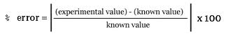

Discussion Question:
1. Given that the density of water is 0.9973 g/mL at 24°C, predict which materials will float or sink in water:
Material Density (g/cm³) Float or Sink
Cherry wood 0.43
Gold 19.3
Oak wood 0.93
Aluminum 2.7
Frozen water 0.93
Rubber 1.50
Air 0.0013

2. Explain in terms of differences in density and the force of gravity why a hot air balloon rises.

3. Explain why heating air changes its density (Hint: think in terms of how energy affects the motion of particles)

