Honors Chemistry Hour_____ Name_________________________________________
Dr. Wexler
Magnetic Properties of Transition Metals and Their Ions
Date:
Background
Atoms or ions that have only paired electrons (i.e., no unpaired electrons) are essentially unaffected by a magnetic field. These atoms or ions are classified as diamagnetic. The magnetic moments of the paired electrons are effectively cancelled out.
A paramagnetic substance is defined as possessing at least one unpaired electron. In a paramagnetic solid, the unpaired electrons of the atoms or ions are not influenced by the electrons on adjacent atoms or ions. The magnetic moments on the individual ions are randomly oriented. However, when subjected to a magnetic field, the magnetic moments become aligned roughly parallel to each other, producing a net attractive interaction with the magnet.
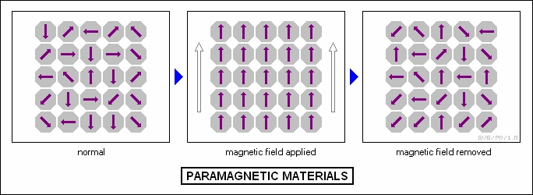

Objective
In this lab you will first predict whether or not a given metal or metal salt will exhibit paramagnetic or diamagnetic properties. You will do this by completing an electron orbital diagram for each substance and analyzing each diagram for the presence or absence of unpaired electrons. You will also be able to predict which of the paramagnetic materials should exhibit the strongest magnetic effect based on the number of unpaired electrons; the more unpaired electrons the stronger the effect. If all the electrons are paired, then the substance will not respond to a magnet and is classified as diamagnetic.
Materials
0.05 mole of each of the following 13 metals or metal ions have been placed inside plastic vials:
CaCl₂ SnCl₂
Mn FeSO₄
MnO₂ FeCl₃
MnCl₂ Cu
CoCl₂ CuCl₂
Zn CrCl₃
ZnSO₄
Pre-Lab
Fill in the following electron orbital diagram blank along with the electron configuration for each of the 13 substances provided:
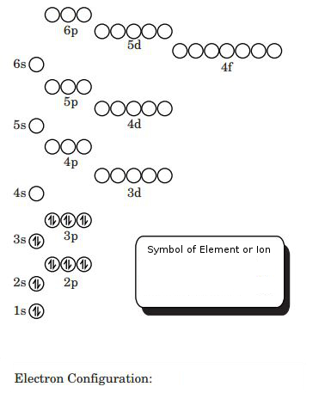
Prediction: Prediction:

Prediction: Prediction:
Prediction: Prediction:

Prediction: Prediction:

Prediction: Prediction:

Prediction: Prediction:
Prediction:

Procedure:
Each lab team is provided with a digital scale with a powerful neodymium magnet taped to the pan. Do NOT remove the magnet! DANGER! Do NOT allow any steel object or especially another magnet to come close to the magnet attached to the pan of the scale. The attraction of very strong magnets could cause physical harm if your hand should get in the way!
- Zero the scale containing the magnet (“tare”)
- Hold a vial containing a known substance as close as possible above the magnet without touching it. Record the change in “mass”. Note: this will be a negative value since the substance is pulling the magnet and therefore the pan of the scale upward.
- Record your result in the Table of Results alongside your prediction for that substance.
- Repeat with the other substances.

Results:
Symbol of Metal or Ion | Number of Unpaired Electrons | Prediction (P or D)  P = paramagnetic  D = diamagnetic | Experimental Result  (P or D) | Mass Deflection (g)

Discussion:
You should have observed that only substances having unpaired electrons exhibit paramagnetism. If not, repeat the experiment for that substance to confirm or correct your result. See your instructor if you are unable to confirm your prediction.
Since the degree of paramagnetism should be dependent on the number of unpaired electrons, then substances having a greater number of unpaired electrons should show a greater mass deflection of the digital scale. Order your paramagnetic substances in order of the number of unpaired electrons, from least to greatest. Compare this order side-by-side in the following table with your mass deflection data.
Symbol of Paramagnetic Metal or Ion | Number of Unpaired Electrons | Mass Deflection (g)

Conclusion:
Was the magnitude of mass deflection consistent with the number of unpaired electrons in all cases? If not, what is a possible explanation (eg. experimental error – be specific).

