Honors Chem Hour_____ Name________________________________________
Dr. Wexler
Lab: Making Slime
Date:
Background:
Guar gum is also known as guaran or galactomannan. The endosperm of the seeds of Cyamopsis tetragonolobus are ground to make guar gum.
Guar gum is used as a food emulsifier, stabilizer and thickener. It has five to eight times the thickening power of starch. Guar gum is often used as a stabilizer and binder to extend the shelf life of ice cream. Antacid tablets use guar gum in some formulations as a binder.
The guar gum in water makes what's called a colloid; a pot full of long stringy molecules, like a bowl of spaghetti. The borax acts like connectors, causing these long guar gum strings to stick to each other forming a large network filled with water. Like Oobleck, slime is a shear-thickening fluid, meaning that it becomes harder when it is stressed.
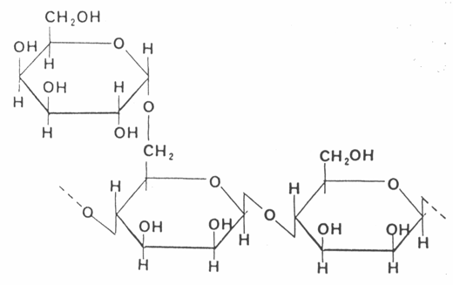

Procedure:
1. Add 15 mL warm tap water to a cup.
2. Stir 0.10 g of borax into the water until dissolved.
3. In a separate cup: add 100mL warm tap water.
4. Stir 1.0g of guar gum into the water until dissolved (about 3-4 minutes).
5. Add food coloring to the guar gum solution.
6. Pour the borax solution into the guar gum solution and stir for about 1 minute or until the slime has fully gelled.

Observations:
Part A: Density
1. Measure the mass of the slime (to one decimal place): ___________ g
2. Measure the volume of the slime (to the nearest mL): __________ mL
3. Calculate the density of the slime to one decimal place:
____________ g/mL
4. Predict whether the slime will float or sink in water based on the density of your slime relative to the density of water (0.994g/mL)
The slime will _________________

5. Test your prediction by pinching off a small chunk of the slime and adding it to a cup filled with water. What do you observe?

6. Does this support your prediction?

Part B: Physical characteristics
1. Pick up the slime and pull it slowly apart. What happens?

2. Pick up the slime and pull it quickly apart. What happens? Is there a difference compared to “slowly”? If so, describe the difference.

3. Throw the slime onto the table. What happens? Does it hold together or split apart? Did it bounce like a solid or splash like a liquid, or somewhere in between?

4. Hit the slime on the table with your hand. What happens? Is there a difference between hitting it hard vs. pushing slowly?

