Chem 1 Hour_____ Name______________________________________________
Dr. Wexler
Phase Changes in Water Practice
Date assigned:

Answer the following questions based on the Phase Change Diagram below:
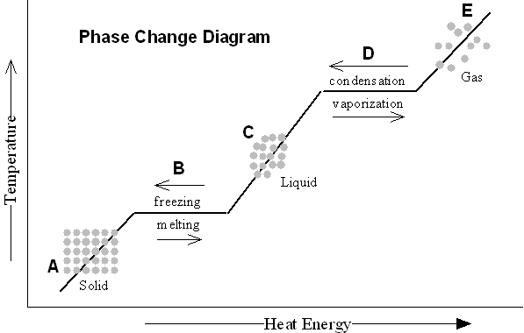
*When one applies heat/energy to a substance, that substance may change its state of matter.
1. According to the diagram, what is the difference between the way molecules in solid water and liquid water are arranged?

2. According to the diagram, what is the difference between the way molecules in liquid water and gaseous water are arranged?

3. What is heat causing the molecules to do that helps explain their phase changes?

4. What happens to the volume of water when it changes from a liquid to a gas? What happens to its density?

5. Frozen water floats on liquid water. Explain why that occurs using the concept of density.

6. According to the diagram, does the temperature change during phase changes or does it only change between phase changes?

8. What is the definition of condensation?

9. Explain why the outside of a glass of ice water is usually wet. Under what circumstance would it remain dry?

10. What is the freezing point of water in degrees Celsius?

What is its melting point?

What is its boiling point?

11. Explain why spreading salt on an icy sidewalk causes the ice to melt.

