Chem 1 Hour_____ Name_________________________________________________
Dr. Wexler/Ms. Steinhorst
Density Quiz
Date:
Part I: Multiple Choice: circle the single best answer in each problem
1. ___ is the amount of matter an object has.
- Weight b) mass c) volume d) density
2. A graduated cylinder is used to measure_____.
- Weight b) mass c) volume d) density
3. If we use the units of grams (g) for mass and cubic centimeters (cm³) for volume, then the units for density will be
a) grams b) cm³ c) Kg/m³ d) g/cm³
4. The mass of an object is 6 kg on earth. On the moon, where the force of gravity is 1/6 that of the earth, the mass of the object would be
a) 6 kg b) 0 kg c) 1 kg d) 3 kg
5. A cube has a side of 5 cm. It has a mass of 250 grams. The density of the cube is
a) 50 g/cm3 and will float in water
b) 2.0 g/cm3 and will float in water
c) 50 g/cm3 and will sink in water
d) 2.0 g/cm3 and will sink in water
6. Liquid water is more dense than ice because
a) A liquid H ₂0 molecule has more mass than an ice H ₂0 molecule.
b) A chemical change occurs when ice melts that causes the mass of water to increase
c) When ice melts there is an increase in the amount of water molecules
d) There are a greater number of H₂0 molecules per unit of volume in liquid water than ice.
7. Which of the following will cause the mass of a metal block to increase
a) putting the block in the freezer
b) measuring the mass of the block on Jupiter
c) heating the block
d) None of the above
8. The density of an object is
a) The mass divided by the volume D = m/v
b) The volume divided by the mass D = v/m
c) The same as its weight
d) The same as the size of the object

9. If two objects have the same volume but one has a greater mass, the one with greater
mass
a) Has a lower density
b) Has a higher density
c) Will float
d) Will sink

10. If you cut a wooden block in half, each half would have
a) Half the density of the original piece
b) Twice the density of the original piece
c) The same density as the original piece
d) No density at all

11. If two objects have the same mass but different volumes
a) The one with the larger volume has the lower density
b) They must have the same density
c) The one with the larger volume has the higher density
d) The one with the larger volume is twice as dense

12. Density is a characteristic property of a substance. This means that the density of water
a) Changes depending on the volume
b) Stays the same regardless of how much you have
c) Is greater for a greater mass of water
d) Is less for a smaller mass of water

Part II: Short Answer
13.
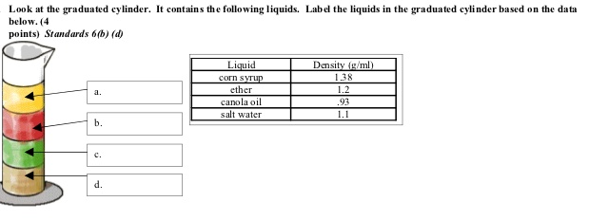
14. Define the term “density” as it applies to chemistry:

15. What is the difference between mass and volume?

16. What are the SI (Standard International) base units for mass and volume?
A. Mass:
B. Volume:
17. What is the derived unit for density if you use SI base units for mass and volume?
18. If a balloon is filled with hydrogen gas it will rise through the air. This is because hydrogen has a lower density than air.
Write a general statement describing the relationship between a substance’s density and its tendency to float or sink in the presence of a second substance:

19. In terms of your answer to question 18 above, explain why iron sinks in water:

20. In science class, two students found the mass of an object to be 50 grams and the volume to be
20 cm³. Calculate the density. Show all work.

21. Will the object in problem 20 sink or float?_________________ Explain your answer.

Use the illustration on the right to answer questions 22-23. The illustration shows evidence of the relative densities of some common substances. The black cube is made of plastic.
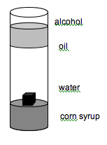

22. Which substance is most dense?

A. black cube
B. alcohol
C. water
D. corn syrup

23. What do you know about the density of the black cube?

A. it is less dense than the alcohol and the water
B. it is more dense than the corn syrup and the water
C. it is more dense than the water and less than the corn syrup.
D. it is more dense than the corn syrup and less dense than the alcohol.

