Honors Chemistry Hour_____ Name_________________________________________________
Dr. Wexler
Quiz 2: Density
Date:

1. 5mL of a secret new drug called compound H has a mass of 4 g. 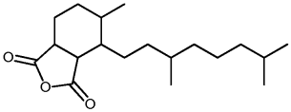
A. What is the density of compound H? Show your calculations using the format below:
What you know: Mass = ________g
Volume = ________cm³
Density formula solved for density: d = m/V
Substitute into the formula and solve. Express your answer in g/cm³
d =

B. Based on the quantitative information given, explain how you know that compound H is not a gas.

C. Will compound H float in water? Explain why or why not.

D. If compound H is mixed with water, will the density of the mixture be more dense or less
dense than that of water? Explain your answer.

2. What formula do you use to calculate the volume of a rectangular prism?

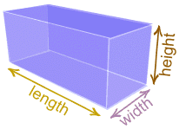

3. Use the above formula to determine the volume of a piece of wood.
Length = 20 cm
Width = 10 cm
Height = 5 cm
Volume = ?
Show all calculations:

