Chem 1 Hour_____ Name________________________________________
Wexler/Steinhorst
Radioactive Decay Practice 2
Date:

1. Draw the symbol for an alpha particle, including its atomic number and mass number.

2. The beta particle is the same thing as an __________________________
3. When a beta particle is emitted, a neutron is converted into a _________________________
4. Which type of decay results in a decrease in atomic mass – alpha decay, beta decay, or both?
5. Which type of decay results in a decrease in atomic number – alpha decay, beta decay, or both?
6. Which type of decay results in an increase in atomic number – alpha decay, beta decay, or both?
7. Write the nuclear equation for the beta decay of Plutonium-244.

8. Write the nuclear equation for the alpha decay of Americium-241.

9. What is a radon daughter atom? Why are these dangerous even though they are short-lived? (see figure on next page)

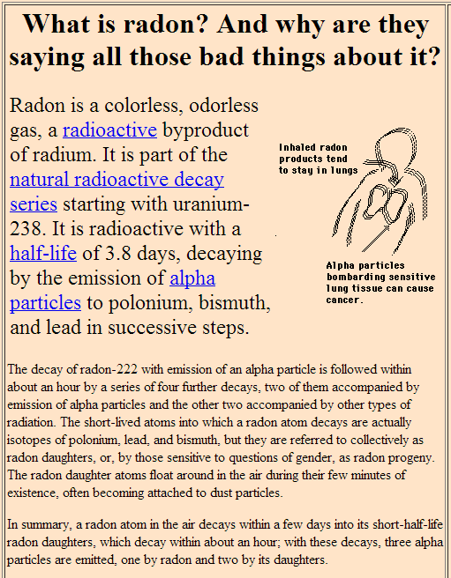
10. Write the set of nuclear equations (decay series) for the decay of Rn-222 (at.num. = 86) all the way to nonradioactive Pb-206 (at.num. = 82).
Step 1. alpha decay:
Step 2. alpha decay:
Step 3. beta decay:
Step 4. beta decay:
Step 5. alpha decay:
Step 6. beta decay:
Step 7. beta decay:
Step 8. alpha decay:

- ²²²Rn, 3.8 days, alpha decaying to...
²¹⁸Po, 3.10 minutes, alpha decaying to...
- ²¹⁴Pb, 26.8 minutes, beta decaying to...
- ²¹⁴Bi, 19.9 minutes, beta decaying to...
- ²¹⁴Po, 0.1643 ms, alpha decaying to...
- ²¹⁰Pb, which has a much longer half-life of 22.3 years, beta decaying to...
- ²¹⁰Bi, 5.013 days, beta decaying to...
- ²¹⁰Po, 138.376 days, alpha decaying to...
- ²⁰⁶Pb, stable.

