Honors Chemistry Hour_____ Name________________________________________
Dr. Wexler
Radioactive Decay Worksheet 2
Date assigned:

1. Draw the symbol for an alpha particle, including its atomic number and mass number.

2. The beta-minus particle is the same thing as an __________________________
3. When a beta-minus particle is emitted, a neutron is converted into a _________________________
4. Which type of decay results in a decrease in atomic mass – alpha decay or beta decay?
5. Which type of decay results in an increase in atomic number – alpha decay or beta decay?
4. If Plutonium-244 emits an alpha particle, what isotope does it become? (Write the name of the element and draw the isotope symbol, including its atomic number and mass number)

5. If Plutonium-244 emits a beta-minus particle, what isotope does it become? (Write the name of the element and draw the isotope symbol, including its atomic number and mass number)

6. What is a radon daughter atom? Why are these dangerous even though they are short-lived? (see figure on next page)

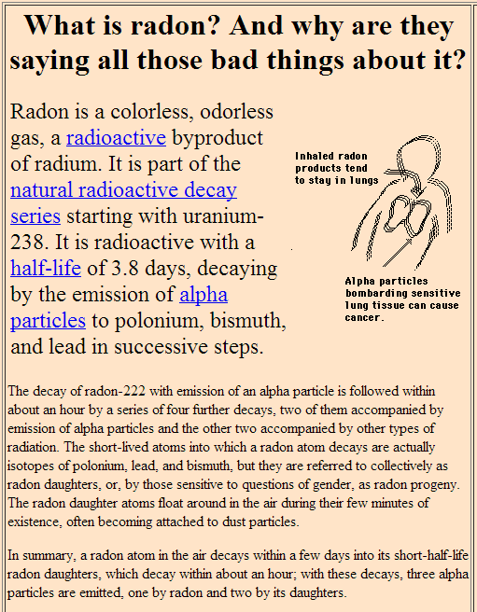
6. Write the decay series for Rn-222 to Pb-206.
Step 1. alpha decay: Rn-222
Step 2. alpha decay:
Step 3. beta decay:
Step 4. beta decay:
Step 5. alpha decay:
Step 6. beta decay:
Step 7. beta decay:
Step 8. alpha decay:

- ²²²Rn, 3.8 days, alpha decaying to...
²¹⁸Po, 3.10 minutes, alpha decaying to...
- ²¹⁴Pb, 26.8 minutes, beta decaying to...
- ²¹⁴Bi, 19.9 minutes, beta decaying to...
- ²¹⁴Po, 0.1643 ms, alpha decaying to...
- ²¹⁰Pb, which has a much longer half-life of 22.3 years, beta decaying to...
- ²¹⁰Bi, 5.013 days, beta decaying to...
- ²¹⁰Po, 138.376 days, alpha decaying to...
- ²⁰⁶Pb, stable.

