Chem 1 Hour_____ Name____________________________________________
Dr. Wexler
Science and Engineering Preassessment
Date assigned:
Show all calculations where relevant.
Part A. Matter: Elements and Atoms, Compounds and Molecules
1. Give the name of each of the following elements:
(a) C
(b) K
(c) Cl
(d) P
(e) Mg
(f) Ni
2. Give the symbol for each of the following elements:
(a) barium
( b) titanium
(c) chromium
(d) lead
(e) arsenic
(f) zinc
3. In each of the following pairs, circle the substance which is a compound.
(a) Na and NaCl
(b) sugar and carbon
(c) gold and gold chloride
(d) copper and copper(II) oxide
(e) silicon and sand
(f) Pt(NH₃)₂Cl₂ and Pt

Part B. Physical and Chemical Properties
4. In each case, decide whether the underlined property (or change) is a physical or chemical property (or change).
(a) The normal color of elemental bromine is orange.
(b) Iron turns to rust in the presence of air and water.
(c) Hydrogen can explode when ignited in air.
(d) The density of titanium metal is 4.5 g/cm³ .
(e) Tin metal melts at 505 K.
(f) Water vapor in your exhaled breath condenses in the air on a cold day.

Part C. Using Density
5. A piece of silver metal has a mass of 2.365 g. If the volume is 0.225 cm³, what is the density of silver?

Part D. Accuracy, Precision, and Error
6. The accepted value of the melting point of pure aspirin is 135 °C. To verify that value, you obtain the melting points of
134 °C, 136 °C, 133 °C, and 138 °C in four separate trials. A different student finds melting points of 138 °C, 137 °C, 138 °C, and 138 °C.
(a) Calculate the average value and percent error for your results and for the other student’s results.
Note: average = sum/#values summed
Note: % error = absolute value of 100 x (experimental – expected)/expected
You) average:
percent error:
Other) average:
percent error:

(b) Which of you is more precise? More accurate? Explain.

Part E. General Questions
7. You have a sample of a white crystalline substance from your kitchen. You know that it is either salt or sugar. Although you could decide by taste, suggest another property that you could use to determine the sample’s identity. Indicate precisely why that property will allow you tell them apart.

8. You accidentally placed a glass milk bottle in the freezer compartment of a refrigerator overnight. By morning the plastic cap had come off and a column of frozen milk emerged from the bottle. Explain this observation.
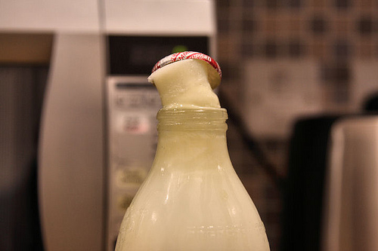

Part F. Scientific Notation
9. Express the following numbers in scientific notation.
(a) 0.054
(b) 5462
(c) 0.000792

10. Express the following numbers in standard notation.
(a) 1.62 x 10³
(b) 2.57 x 10⁻⁴
(c) 6.32 x 10⁻²

11. Carry out the following operations.
(a) (1.52 x 10³) (6.21 x 10⁻⁴)

(b) (1.52 x 10³) / (6.21 x 10⁻⁴)

(c) 6.21 x 10⁴) + (5.23 x 10³)

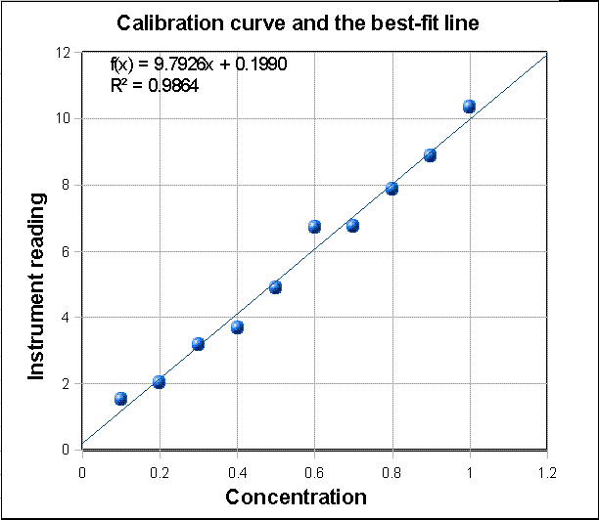
12. Using the graph:
(a) What is the x value when the y = 6?
(b) What is the value of y when x = 1.1?

