Chem 1 Hour______ Name_________________________________________
Dr. Wexler
Sugar and Soft Drinks Practice
Date:
Sugars and Your Health:
Sugars, especially glucose, are a major source of energy for all living things. Plants produce glucose by photosynthesis and convert that and other monosaccharides into various disaccharides such as sucrose (table sugar) or convert it into starch for storage. Sugar may also be just as addictive as cocaine. So even if you’re ready to kick your sugar habit, it might not be as easy as you think.
Although soda is becoming less commonplace in middle and high schools, sports drinks – which are essentially sugar-water by another name – have largely replaced it. Sports drinks were still available to 83% of high school students in 2010. These drinks are a key part of the obesity epidemic that’s spreading among young people.
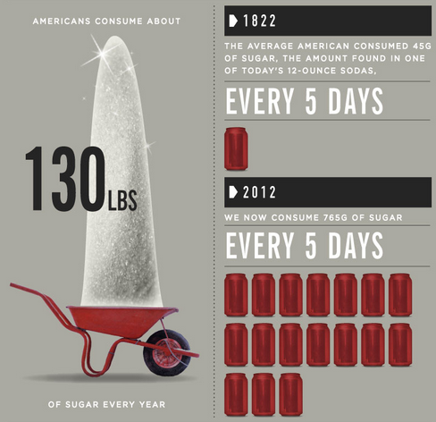

Diabetes
Sugar provides excess calories that are easily and rapidly absorbed by your body. That's one reason your risk of developing type 2 diabetes rises along with sugar consumption. In fact, adding just one sugar-sweetened beverage to your daily diet almost doubles your risk.

Heart Disease
Consuming too many carbohydrates, such as sugar, significantly raises your risk for developing a lipid profile that in turn increases your risk for cardiovascular disease. This consists of higher triglyceride levels, lower "good" high-density lipoprotein cholesterol levels and higher "bad" low-density lipoprotein cholesterol levels.

Other Obesity-related Diseases
Excess sugar intake is associated with weight gain and obesity. Being obese or overweight raises your risk for many health conditions besides diabetes and heart disease. These include high blood pressure, stroke, gallbladder and liver diseases, osteoarthritis, gynecological problems such as infertility, respiratory problems, sleep apnea and colon, breast and endometrial cancers.

Question 1:
In 2012, the average American drank 216 liters of soda in a year.
If each 0.355L contains 39g of sugar, how much sugar is this per year from soda? Per day? Show all calculations.
A. Per year

B. Per day

Question 2:
Refer to the following graph -
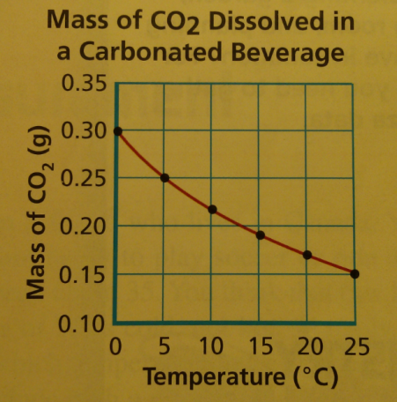
Distilled water in an open container is a mixture, not a pure substance. This is due to dissolved gases. Based on the graph, propose a simple method to completely purify the water by removing the dissolved gasses:

