The world is warming faster than we thought
- 18:00 05 October 2014 by Michael Selzak
It's worse than we thought. Scientists may have hugely underestimated the extent of global warming because temperature readings from southern hemisphere seas were inaccurate.
Comparisons of direct measurements with satellite data and climate models suggest that the oceans of the southern hemisphere have been sucking up more than twice as much of the heat trapped by our excess greenhouse gases than previously calculated. This means we may have underestimated the extent to which our world has been warming.
Paul Durack from the Lawrence Livermore National Laboratory in California in the US and colleagues have compared direct and inferred sea temperature measurements with the results of climate models. While these three types of measurements together suggest that our estimates of northern hemisphere ocean warming are about right, a different story emerged for down south.
The team estimate that the extent of warming in the southern hemisphere oceans since 1970 could be more than twice what has been inferred from the limited direct measurements we have for this region. This means that together, all the world's oceans are absorbing between 24 and 58 per cent more energy than has previously been estimated by direct in-situ measurements.
Wenju Cai from the CSIRO in Melbourne, Australia says the results mean the world is warming faster than we thought. "The implication is that the energy imbalance – the net heating of the earth – would have to be bigger," he says.
"There has been a general acknowledgement in the literature, that southern-hemisphere estimates of ocean warming are likely biased low," says Durack. "Our study is the first to attempt to quantify the magnitude of what this generally acknowledged underestimate is, using as much information as is available."
The study covers the period from 1970 to 2003. Cai says that, during that time, while the northern hemisphere has been well sampled by cargo ships and projects led by wealthy countries north of the equator, very few direct measurements have been taken in the south. So it's not surprising that the in-situ measurements have been wrong. "But this is huge," says Cai.
"One could say that global warming is ocean warming," Gregory Johnson and John Lyman at the US National Oceanic and Atmospheric Administration wrote in a commentary accompanying Durack's paper. "Quantifying how fast, and where, the ocean is warming is vital to understanding how much and how fast the atmosphere will warm, and seas will rise."
Since around 2000, a network of buoys called the Argo floats have been collecting more accurate global ocean data, so more recent measurements of the southern hemisphere are more reliable.
Answer the following questions:
1. Why have temperature readings from oceans in the northern hemisphere been more reliable (until recently) than readings from the southern hemisphere?

2. Why are the southern readings now more reliable?
3. How does this affect predictions about (A) atmospheric warming and (B) sea level rise?

4. What does the following graph reveal about where most of the world’s heat is stored?
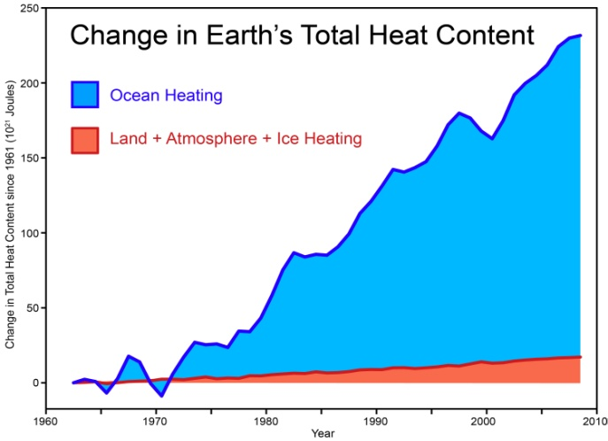
5. Briefly explain why warming of the atmosphere results in trapping of heat in the oceans. See http://www.skepticalscience.com/How-Increasing-Carbon-Dioxide-Heats-The-Ocean.html

