Chem 1 Hour_____ Name_________________________________________
Wexler/Steinhorst
Unit Conversion Explanation Worksheet
Date:
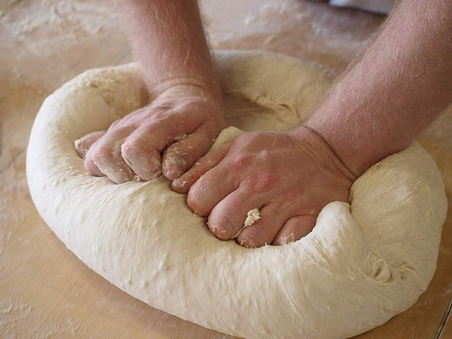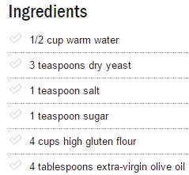
You manager at the bakery asks you to make enough dough for 10 loaves of bread.
You do some quick calculations to scale up the quantities of ingredients. Focusing on flour, you determine that you need 40 cups of flour.
Instead of measuring 40 cups in the mixing bowl, you decide to use the gallon measure instead.
You look up the conversion between gallons and cups and find out that there are 16 cups in a gallon.
Now you have to figure out a way to calculate the number of times you have to fill the gallon measure to measure out 40 cups of flour.
After thinking about it for a while, you consult with your supervisor. She asks you to describe both verbally and in writing (using words, not diagrams) how you will figure out how many gallons are equal to 40 cups.
After giving a verbal description to your partner, you write:

Your supervisor then asks you to give your written instructions to another baker’s helper by the name of
___________________________________________________________, who she asks to diagram the process for calculating gallons by dimensional analysis based exactly on what you wrote.
Your partner creates the following diagram and calculates the number of gallons:

You then use this calculation to measure out the volume of flour needed to make the 10 loaves of bread.
After the bread is baked, your supervisor asks you to sample the product. Are you confident enough in your calculations that you would agree to eat the bread? Why or why not?

